I’m a Nurse….What does BloodSTAR mean for me?
As a Nurse, BloodSTAR means a new way to manage Immunoglobulin (Ig) authorised for your patients.

BloodSTAR is the new online system to standardise and manage access to the supply of Ig products. For Nurses, BloodSTAR will be an electronic way of managing patients authorised to receive IVIg or SCIg.

Nurses with patients receiving Ig should register for BloodSTAR and will then be able to manage patients within the system. Within BloodSTAR a nurse can;
- view and search authorisation information for each patient located at your facility,
- submit dispense requests as an electronic planning sheet or individual patient requests to the nominated dispenser,
- edit personal patient details, facility information and the patient’s treating medical specialist,
- have clearly visible authorisation records for patients who have reached the required review date; and
- search for patients nationally if a valid reason from the drop down options is provided.

There are four ways that a dispense request can be submitted by the nurse to the dispenser;
- Electronic planning sheet within BloodSTAR,
- Electronic individual dispense request within BloodSTAR,
- Paper based planning sheet external to BloodSTAR, or
- Paper based individual request external to BloodSTAR.

This could mean a process change for your facility, if the electronic BloodSTAR requesting processes are utilised. It is up to the nurse and the dispenser to discuss the best option to apply to suit your needs.

The Australian Red Cross Blood Service (Blood Service) will no longer be accepting patient specific orders. They will still have the role of Authorising patients which will be done via BloodSTAR. Orders for Ig products will now be through a dispenser, who will order product through BloodNet.
It will be the dispenser’s role to ensure that product for patients is available for the right dose and frequency as per the authorisation.

The National Blood Authority (NBA) and the Blood Service are working to make the transition to BloodSTAR as smooth as possible. If patients have signed the privacy consent, and their treating facility and prescriber are registered in BloodSTAR then the patient will be entered into the system before your State/Territory go live date. To know if your patients have provided privacy consent, contact your local Blood Service Authoriser. To learn about your go live date please refer to the table below, for more detail go to www.blood.gov.au/bloodstar.

Facility registration - now open*
To register your facility, both private and public, please go to the following link to fill and submit the form www.blood.gov.au/registering-your-facility-bloodstar.

User registration - open on 4 April 2016.
The BloodSTAR nurse role encompasses all nurses who are registered with the Australian Health Practitioners Regulation Authority (AHPRA). It is essential that you and your colleagues register for BloodSTAR as soon as possible from 4 April 2016.

*NSW public laboratories, hospitals and staff (prescribers, nurses and dispensers) are not required to register until further notice. The NBA is working directly with NSW Health to develop suitable arrangements for the state wide implementation of BloodSTAR. The NBA is responsible for implementing BloodSTAR in the private sector in NSW so private facilities and staff (prescribers, nurses and dispensers should follow the instructions provided by the NBA.

BloodSTAR preparation checklist:

Facility registrations –facilities at which I work are registered for BloodSTAR
- all facilities that treat patients and administer Ig must be registered for BloodSTAR. You should discuss this with hospital or practice managers to ensure facilities at which you work are registered, this includes private clinics and medical centres. To register your facility, go to www.blood.gov.au/registering-your-facility-bloodstar.

I’m registered as a BloodSTAR user
- Registrations open on 4 April 2016. You can create one login for all the locations you work at and submit an access request for each location.

I have discussed the process for dispense requests with my nominated dispenser(s)
- Dispense Requests – Discuss and decide which type of dispense request you will use with your dispenser before your go live date and set up a process to ensure this takes place from go live date onwards.

Read the Ig product nurse/midwife roles and responsibilities within the Ig Governance National Policy which is available from www.blood.gov.au/Ig-program .

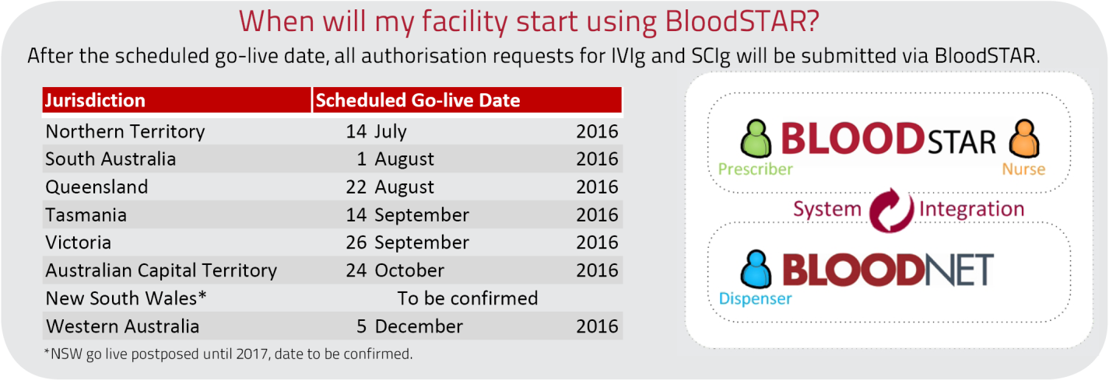

For further information and support please contact the NBA Health Provider Engagement Team on
13 000 BLOOD (13 000 25663) or support@blood.gov.au.

