I’m a Prescriber….What does BloodSTAR mean for me?

As a prescriber of Immunoglobulin (Ig) products, BloodSTAR means you will manage your authorisation requests and review outcomes for Ig product via a new electronic system.

This information sheet provides a useful checklist to help you prepare for BloodSTAR implementation.

What is BloodSTAR?

BloodSTAR is the new online system which will standardise and manage access to the supply of Ig products. The Australian Red Cross Blood Service (Blood Service) will continue in their role as the authorisers of Ig products but, with the introduction of BloodSTAR, all current paper-based authorisation request forms and review letters will be replaced by electronic processes.

What will I be able to do on BloodSTAR?

Once BloodSTAR is live in your State/Territory, prescribers will use BloodSTAR to;

- Create initial authorisation requests
- View authorisation requests, including assessment status
- Submit dose change requests
- Request additional doses
- Search and create patients
- View list of all patients where you are either the;
  - treating medical specialist
  - requesting medical officer
  - diagnosing medical officer, or
  - verifying diagnosing medical officer
- View list of all patients at the facility your logged into
- Submit transfer of care if a patient moves specialist or their treating, administering or dispensing facility
- Record review outcomes
- Request continuing authorisation
- Request product from dispenser
- Receive notifications

When will BloodSTAR go live in my State/Territory?

To learn about your go live date, please go to www.blood.gov.au/bloodstar.

Can my currently authorised patients be entered into BloodSTAR before the system goes live in my State/Territory?

The National Blood Authority (NBA) and the Blood Service are working to make the transition to BloodSTAR as smooth as possible.

Currently authorised patients will be entered into BloodSTAR before their State/Territory go live date if:
- They have been authorised to receive Ig beyond the go live date;
- They have provided privacy consent and a copy of the privacy consent has been forwarded to the Blood Service;
- Their treating facility has been registered; and
- Their treating medical specialist has registered.

How can I find out if the Blood Service has a copy my patient’s privacy consent?

Please contact your local Blood Service Medical Services team.

When and how can I register my facility on BloodSTAR?

Facility registration is now open*

To register your facility, both private and public please go to the following link, fill and submit the form www.blood.gov.au/registering-your-facility-bloodstar.

When and how can I register to use BloodSTAR?

User registration will open on 4 April 2016. Information on when and how to register will be made widely public from 4 April onwards. To know how to register please go to www.blood.gov.au/bloodstar-support-materials from 4 April 2016 onwards.

Do all doctors need to register?

The BloodSTAR prescriber role encompasses interns, residents, registrars, consultants and accredited nurse practitioners.
- All treating medical specialists MUST register to manage ongoing care of their patients.
- Other medical officers who may be involved in the care of patients requiring Ig treatment must be registered before they can access the system, e.g., to submit authorisation requests or view a patient’s authorisation status.

It is essential that you and your colleagues register for BloodSTAR as soon as possible from 4 April 2016.

*NSW public laboratories, hospitals and staff (prescribers, nurses and dispensers) are not required to register until further notice. The NBA is working directly with NSW Health to develop suitable arrangements for the state wide implementation of BloodSTAR. The NBA is responsible for the implementing BloodSTAR in the private sector in NSW so private facilities and staff (prescribers, nurses and dispensers should follow the instructions provided by the NBA.

Prescriber BloodSTAR preparation checklist:

Patients have provided privacy consent and a copy has been forwarded to the Blood Service
- Patient privacy consent – All your patients must consent to their personal and sensitive information being stored in systems owned by the NBA and the Blood Service. To access the form go to www.blood.gov.au/Ig-forms. To confirm whether the Blood Service has been provided with a copy of your patient’s privacy consent, contact your local Blood Service Medical Services team.

My facilities are registered
- Facility registration – all facilities that you work at must be registered, including private clinics and medical centres. To register your facility, go to www.blood.gov.au/registering-your-facility-bloodstar.

I’m registered for BloodSTAR
- User registration – you must register for BloodSTAR. Registrations open on 4 April 2016. You can create one login for all the locations you work at and submit an access request for each location. It is essential that Prescribers register as soon as possible to ensure that ongoing authorised patients are matched to the Treating Medical Specialist when entered into BloodSTAR by the Blood Service.

I have agreed on and set up a dispense process for my facility
- If you currently submit planning sheets to the Blood Service to order product for authorised patients, these now need to be directed to the dispenser. You should discuss with your dispenser how dispense requests should be submitted once BloodSTAR goes live, either electronically in BloodSTAR or as paper-based requests.

I’m ready for the go live date
- Be aware of your State/Territory go live date. All new authorisations and any dose changes, additional dose, review outcomes and continuing authorisation requests MUST be completed in the system from this go live date onwards.

Agree on and set up a dispense process for your facility
- If you currently submit planning sheets to the Blood Service these now need to be directed to the dispenser. You should discuss with your dispenser how dispense requests should be submitted once BloodSTAR goes live, either electronically in BloodSTAR or as paper based requests.

I have read and understood the Ig product prescriber roles and responsibilities within the Ig Governance National Policy which is available from www.blood.gov.au/Ig-program

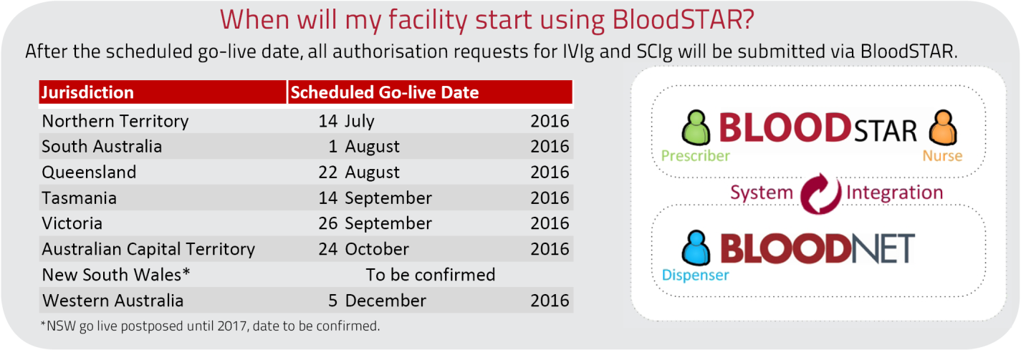

For further information and support please contact the NBA Health Provider Engagement Team on
13 000 BLOOD (13 000 25663) or support@blood.gov.au.

