I’m a Dispenser….What does BloodSTAR mean for me?

As a dispenser you will use a new tab labelled Authorisations in BloodNet that will contain all the information on patients authorised for product that are linked to your facility.

BloodSTAR will be the new online system to standardise and manage access to the supply of Ig products. Dispensers will have no requirement to access BloodSTAR, all relevant information will flow between BloodNet and BloodSTAR.

Once BloodSTAR is live, dispensers will have information/options available within BloodNet such as;
- Ability to search BloodNet patient records for Ig products
- View list of authorised patients at logged in facility
- View dispense requests
- Action dispense requests
- View dispense discrepancies
- Reconcile dispensed product against authorisation records
- View and action unmatched dispense episodes
- Order Ig products from the Blood Service as stock, for planned dispenses

Key Changes for Dispensers:

- Dispensers will be responsible for ensuring that Ig is dispensed in accordance with the authorisation. The information in the BloodNet Authorisations tab will assist the dispenser to undertake this new role ensuring that only authorised patients are dispensed Ig products, and that they are dispensed the correct product, the correct dose, and within the correct interval.

- Dispensers will be responsible for ordering all Ig products from the Blood Service. Planning sheets will no longer be accepted by the Blood Service from nursing and prescribing staff, these should be redirected to the dispenser to verify and check before dispensing product against the request. Planning sheets will be able to be electronically lodged to BloodNet using BloodSTAR.

- Dispensers must coordinate with their nurses/prescribing staff to determine how each facility that they work with will submit dispense requests. Will dispense requests be action in the system or externally? And will they be submitted via planning sheets or individual requests?

- Orders will be placed within BloodNet as a stock order, based on clinical demand for the products you require for your authorised patients. A report will be available in BloodNet to provide a forecast of the Ig stock required to give coverage for scheduled infusions for authorised patients over the time period you select.

- Patient specific orders should no longer be sent to the Blood Service for IVIg and SCIg, to comply with privacy requirements under the Australian privacy principles.

- All Ig dispense episodes must be recorded in BloodNet. If you have a Laboratory Information System (LIS) interface you can record this dispense in your LIS and the information will flow back to BloodNet and then BloodSTAR. For more information on LIS interfacing please go to http://www.blood.gov.au/bloodnet/lis-interfaces.

- If product is dispensed outside the constraints of the authorisation the dispenser will need to action this on the Dispense Discrepancies page under the new Authorisations tab in BloodNet. This action will be required if a different product, higher dose or shorter frequency is dispensed to the patient.

- Dispensers with a LIS interface will also need to monitor the Unmatched Dispense episodes page under the Authorisations tab and regularly action dispense episodes that are made in their LIS but cannot be automatically matched in BloodNet. For example, this may be caused by a misspelled name in their LIS or BloodSTAR and once corrected should not occur again.

For more information and guidance refer to the Managing Blood and Blood Product Inventory: Guidelines for Australian Health Providers – Module 2: Intravenous and Subcutaneous Immunoglobulin coming soon on the National Blood Authority website www.blood.gov.au.

Dispensers BloodSTAR/BloodNet preparation checklist:

Discussed with nurses/prescribers how requests for product to be dispense will be received.
- Dispensers should discuss with nurses from all facilities that you dispense to how you would like your dispense requests to be submitted. Options for the nurse/prescriber to action in BloodSTAR are as a planning sheet or an individual dispense request. Options for nurse/prescribers external to BloodSTAR are as a paper based planning sheet or as a paper based individual dispense request.

BloodNet stock template updated to include relevant Ig products.

Read the Ig product dispenser roles and responsibilities within the Ig Governance National Policy.

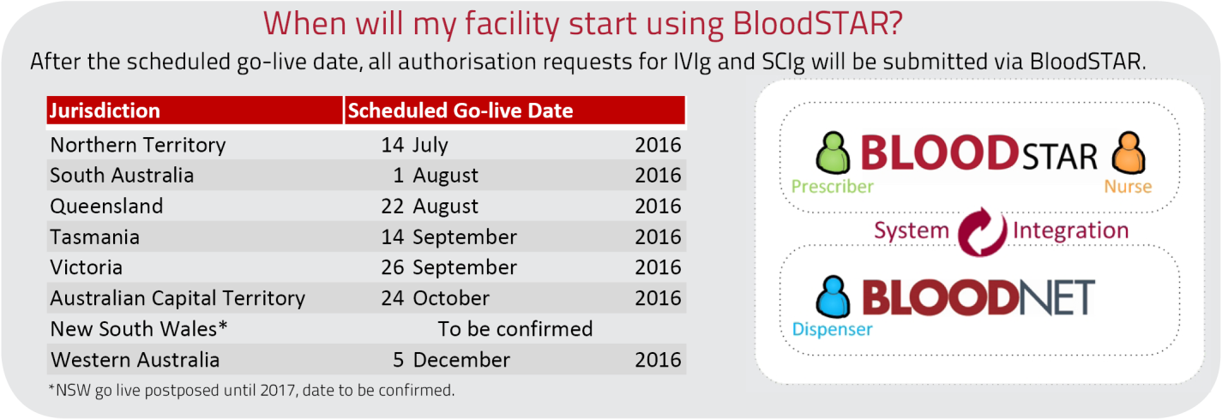
For further information and support please contact the NBA Health Provider Engagement Team on
13 000 BLOOD (13 000 25663) or support@blood.gov.au.

