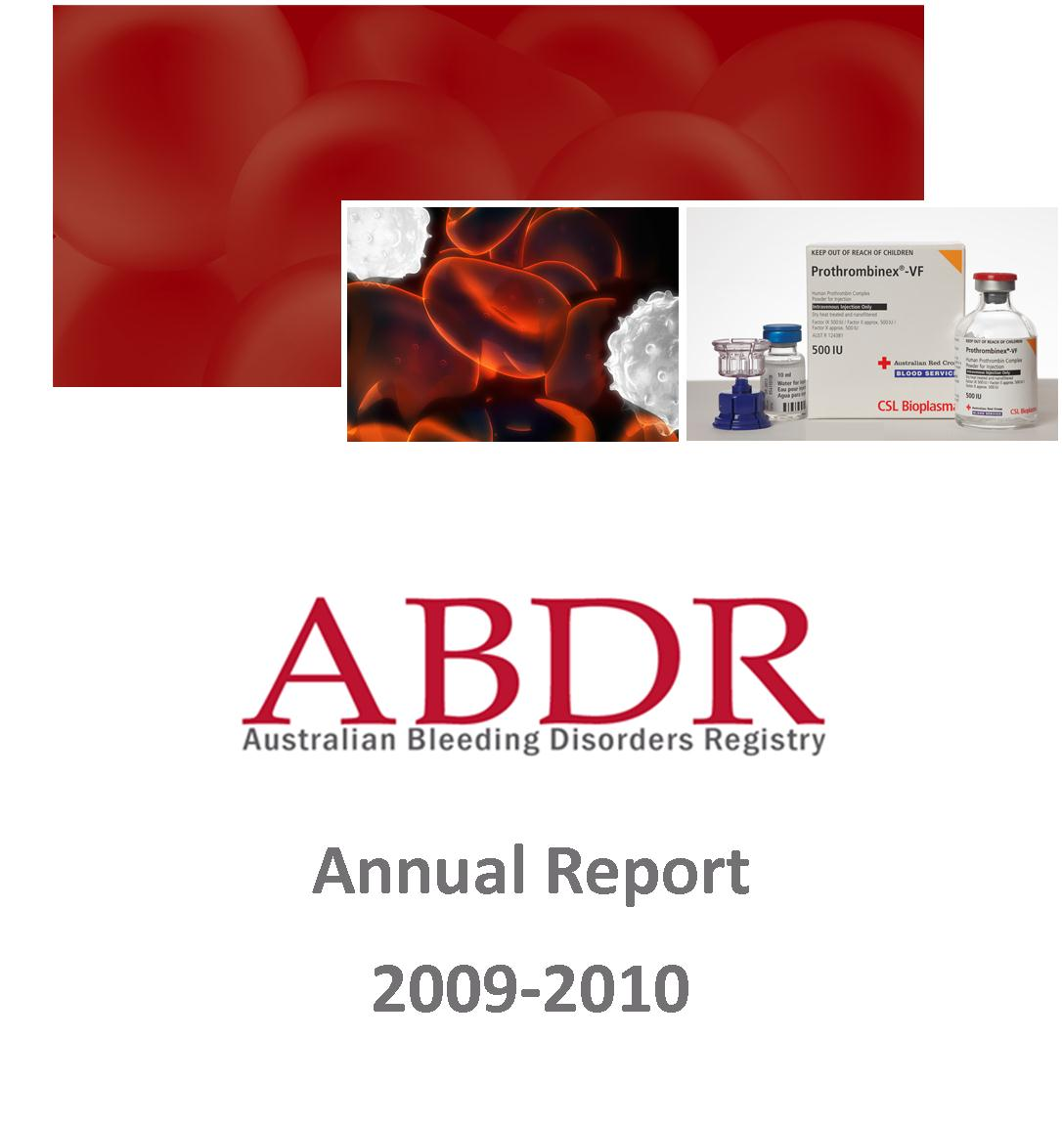

Creative Commons
With the exception of the Australian Bleeding Disorders Registry (ABDR) logo, this document is licensed under a Creative Commons Attribution 3.0 Australia licence.
The document should be attributed as the Australian Bleeding Disorders Registry Annual Report 2009-2010 published by the National Blood Authority.

ISSN
ISSN – 1839-0811 (online version)

Publisher Contact Details
National Blood Authority
Locked Bag 8430
Canberra ACT 2601
AUSTRALIA
Telephone – 02 6211 8300
Facsimile – 02 6211 8330
Email – abdr@nba.gov.au

Table of Contents
1. Table of Contents i
1.1. Glossary (main terms) ii
2. Executive Summary 2
2.1. Purpose 2
2.2. Key observations 2
3. Background 4
3.1. What are bleeding disorders? 4
3.2. Treatment arrangements in Australia 5
3.3. What is the ABDR? 6
3.4. ABDR Management and Governance 7
3.5. Data quality issues 7
4. Patients in the Registry 10
4.1. By diagnosis 10
4.2. By geography 16
4.3. Incidence of major disorders 18
4.4. By age distribution 20
4.5. By Inhibitors 22
5. Patients who received treatment 24
5.1. By severity 24
5.2. National average issues of Factor VIII by severity 27
5.4. By weight and height 29
5.5. By age distribution 30
6. Volume and cost of products used in the treatment of bleeding disorders 34
6.1. National issues by product 34
6.2. National Costs for products issued 39
7. Appendices 42
Appendix A Haemophilia Treatment Centres 42
1. The objectives of HTC’s 42
2. Operating concept 42
3. Data Quality of HTC data collections 45
Appendix B History and development of the ABDR 47
1. Benefits of the redeveloped ABDR 47
2. Current position of the development of the ABDR 47
Appendix C ABDR data collection (registration form) 48
Appendix D August 2010 ABDR Newsletter 49
Appendix E 52
List of Figures 52
List of tables 53

Glossary (main terms)
Abbreviation | Meaning
ABDR | Australian Bleeding Disorders’ Registry
AHCDO | Australian Haemophilia Centres Directors’ Organisation
DDAVP | Desmopressin (1-deamino-8-D-arginine vasopressin, abbreviated DDAVP) a derivative of the antidiuretic hormone, used to treat patients with Haemophilia A and von Willebrand disease. It does not come under the national blood agreement funding arrangements and its use in not recorded in the NBA’s issues database.
HFA | Haemophilia Foundation Australia
HmA | Haemophilia A (Factor VIII deficiency)
HmB | Haemophilia B (Factor IX deficiency)
HTC | Haemophilia Treatment Centre
IDMS | Integrated data management system – The NBA’s integrated data management system.
NBA | National Blood Authority
PWBD | People with a bleeding disorder
vWD | von Willebrand disease

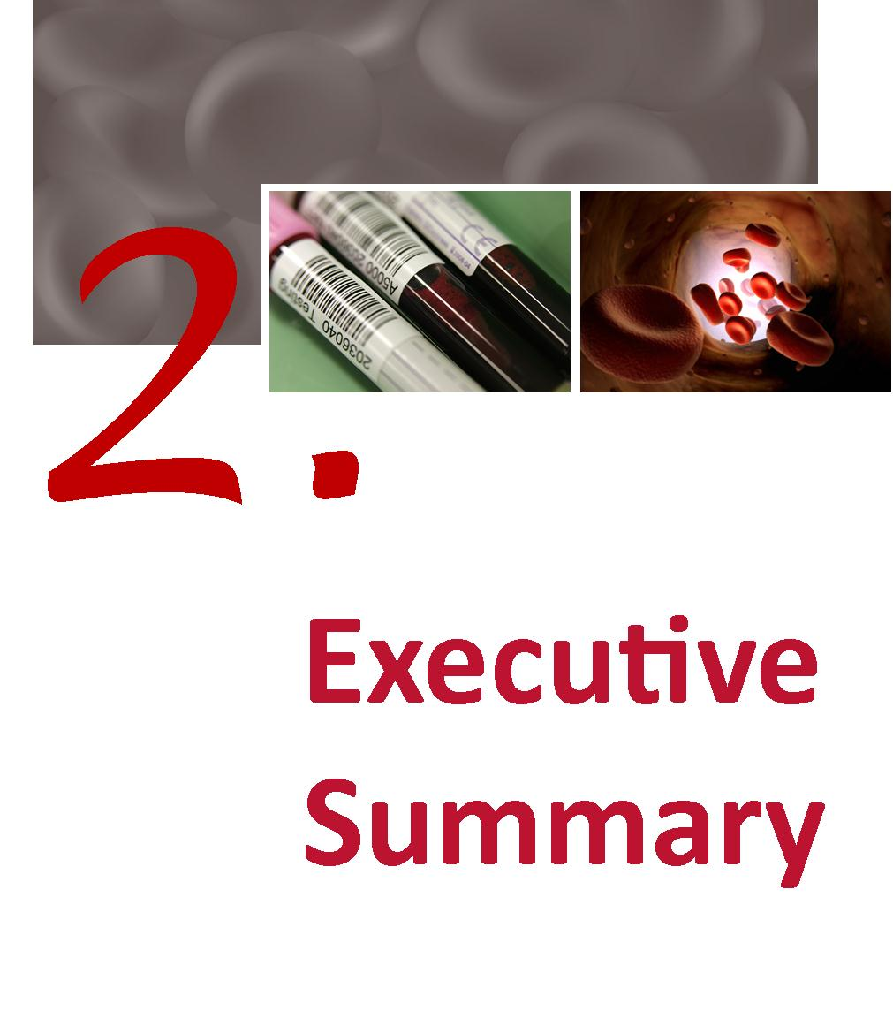

Executive Summary

Purpose
This document draws data from the Australian Bleeding Disorders Registry (ABDR) and other National Blood Authority supply and contract sources to provide an integrated view of current clinical and demographic information on people with bleeding disorders in Australia and the resultant demand for clotting factor products.
It has been developed through the close collaboration of all stakeholders involved in the management and governance of the ABDR, namely:
- Australian Haemophilia Centre Directors’ Organisation (AHCDO)
- Haemophilia Foundation of Australia (HFA) and
- National Blood Authority(NBA).

Key observations
The data contained in the Report shows:
- the number of patients registered increased by 289 from 2008-09 to 2009-10;
- the number of patients with severe diagnosis increased by 28;
- there was no significant change in the proportion of people in the register treated between current data and earlier versions of the ABDR;
- there was a significant increase in the number of people in the register with Factor XI deficiency, albeit the totals are small, and those with von Willebrand disease (vWD); and
- there was an increase in the proportion of people in the register who were females.
These results are tempered by some data quality issues. Some records are incomplete and some product use is not recorded. In some areas inconsistent definitions appear to be used for some fields.
This report represents the first analysis of the ABDR data since a redevelopment in 2008 and allows comparison of data input by jurisdiction to improve collection in deficient areas. The collation of these data also allows some key insight into the way in which product is managed, for example, there is
- variability in dosage regimes by jurisdiction; and
- variability in completeness of data input by jurisdiction and by Haemophilia Treatment Centre (HTC)

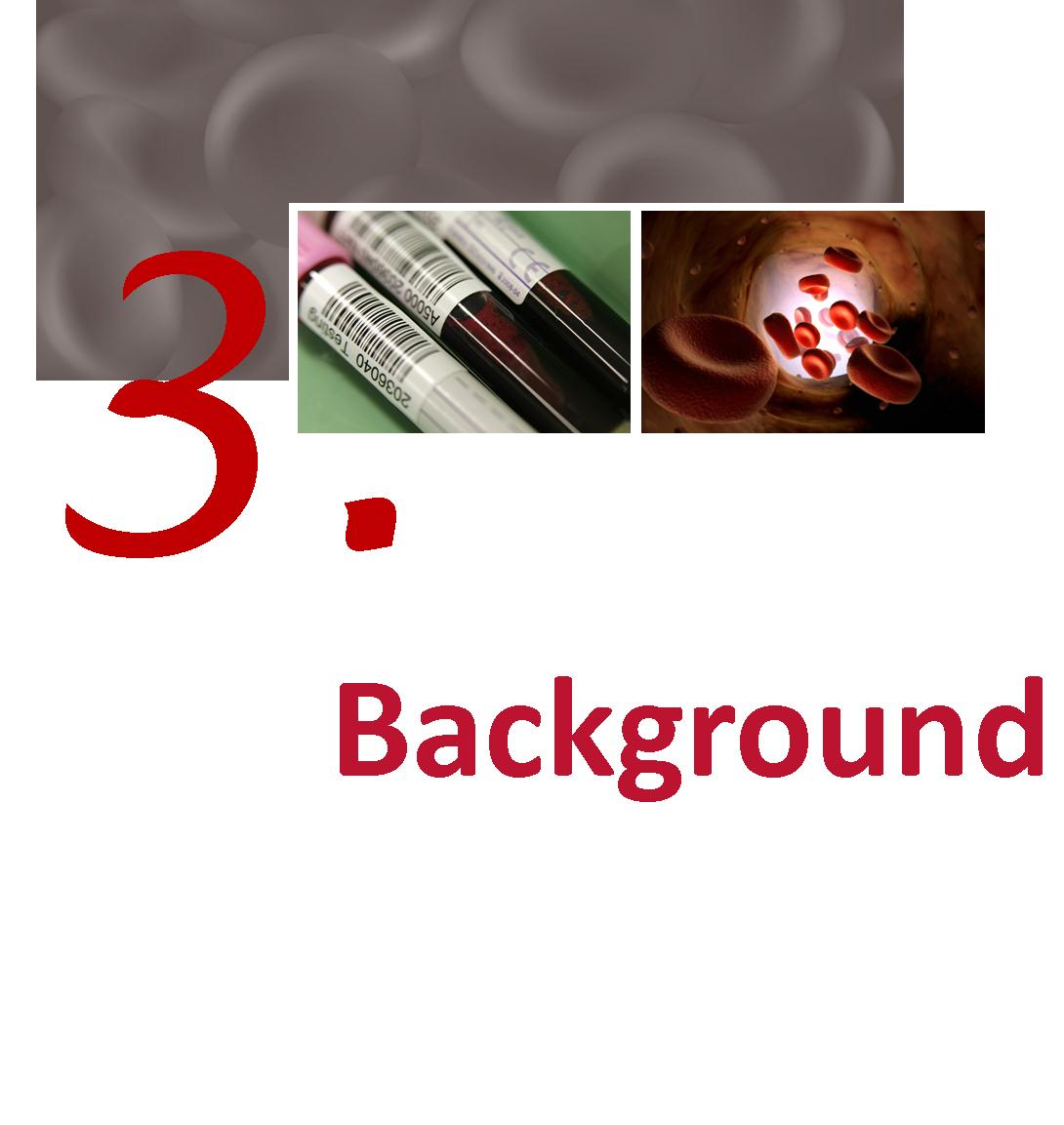

Background

What are bleeding disorders?

Haemophilia
Haemophilia occurs in 1 in 6,000-10,000 males internationally.
In Australia there are approximately 2,300 people with varied degrees of severity of this condition. There are 2 types of Haemophilia:
- Haemophilia A (classical Haemophilia) is the most common type and caused by a deficiency of blood clotting factor VIII.
- Haemophilia B (Christmas Disease) is due to a deficiency of blood clotting factor IX.
The deficiency in clotting factor produces a wide range of bleeding episodes, usually into the joints, muscles or internally possibly affecting vital organs. These bleeding episodes, or “bleeds”, may occur spontaneously, or as a result of trauma or injury. The bleeding is stopped by infusion of the appropriate clotting factor by intravenous injection. Over a period of time bleeding into joints and muscles can cause permanent damage such as arthritis, chronic pain and joint damage requiring surgery.
With appropriate treatment haemophilia can be managed effectively.
Haemophilia is an inherited condition and occurs in families, however in one-third of cases it appears in families with no previous history of the disorder. Haemophilia is due to a mutation in the Factor VIII or factor IX gene which is on the X chromosome. The haemophilia gene is passed down from parent to child through generations. Some women and girls who carry the haemophilia gene may also experience bleeding problems.

von Willebrand disease
von Willebrand disease (vWD) is a related bleeding disorder which affects both men and women. This disorder is more common and is caused by a deficiency and/or malfunction of von Willebrand factor.
Table 1 Major bleeding disorders and their cause
Disorder group | Cause
Haemophilia A | Deficiency in factor VIII
Haemophilia B | Deficiency in Factor IX
von Willebrand Disease | Deficiency in von Willebrand factor
Other factor deficiencies | Deficiency in other coagulation factors.
Platelet Disorder | Deficiency in effective platelets

Severity
Haemophilia A and B are classified according to their severity as this informs the treatment regimens required. The definitions of severity that are applied within the ABDR are listed overleaf. Definition of severity of vWD and other coagulation factor deficiencies is variable.
Table 2 Severity and the concentration of clotting factors
Severity | Concentration of  Clotting Factor | Typical Bleeding Picture
Severe | <0.01 IU/ml (<1% of normal†) | Frequent bleeding episodes common, predominantly into joints & muscles. Bleeding can occur spontaneously or after minor injury.
Moderate | 0.01 – 0.05 IU/ml (1–5% of normal) | Can bleed after minor injury. May have joint bleeding. Severe bleeding with trauma, surgery, invasive procedures.
Mild | >0.05 – 0.40 IU/ml (5-40% of normal)‡ | Spontaneous bleeding does not occur. Bleeding with major trauma, surgery, invasive procedures.
Notes † Normal concentration of factor VIII or IX is defined as 100% or one unit of factor VIII activity per ml of plasma - 100 U/dL (Kasper 2004).
‡ levels of FVIII above 40% are considered sufficient for normal haemostasis.

Treatment of bleeding disorders
Mild conditions may require no treatment or treatment only under special circumstances such as surgery. More severe conditions may require regular interventions. Treatment may occur in a hospital or other medical facility, or at home. The treatments may be regular and preventative (prophylaxis), or on demand (when a bleed occurs).
Often the treatments involve providing replacement for the missing or defective clotting factors. Products used include plasma derived and recombinant clotting factors, cryoprecipitate and Desmopressin (1-deamino-8-D-arginine vasopressin, abbreviated as DDAVP). In some patients, their therapy is complicated when their bodies develop inhibitors that destroy the replacement clotting factors and other treatment is necessary.

Treatment arrangements in Australia
The majority of people with these conditions are treated at Haemophilia Treatment Centres (HTCs) which are specialist centres that provide comprehensive care to people with haemophilia and other coagulation deficiencies. The comprehensive care model ensures that preventative and general treatment on the complex aspects of haemophilia are given in a co-ordinated way by a multi-disciplinary team within the one centre.
Haemophilia Centres were established under a decision by the Australian Health Ministers Advisory Council in 1998 to provide a leadership role within their hospital, city and outlying areas to ensure optimal care and an equitable distribution of professional and therapeutic resources, together with responsible record-keeping. Specific roles of these Centres proposed by this decision are defined in Appendix A.

The manner in which these functions are delivered varies between states including the degree to which they:
- operate within a centralised compared to distributed treatment models;
- focus on treating paediatric or adult patients compared to treating all age groups; and
- have relatively small numbers of patients compared to relatively large numbers – commonly based on geography.
There are also some patients that receive product from clinicians not associated with an HTC. The proportion of product that is used in these circumstances varies across jurisdictions and there is therefore some variability in the data capture rate within jurisdictions. Accordingly, data on total volume of products recorded from the ABDR may not be consistent with data provided by the NBA from other sources.

Figure 1 Location of HTCs
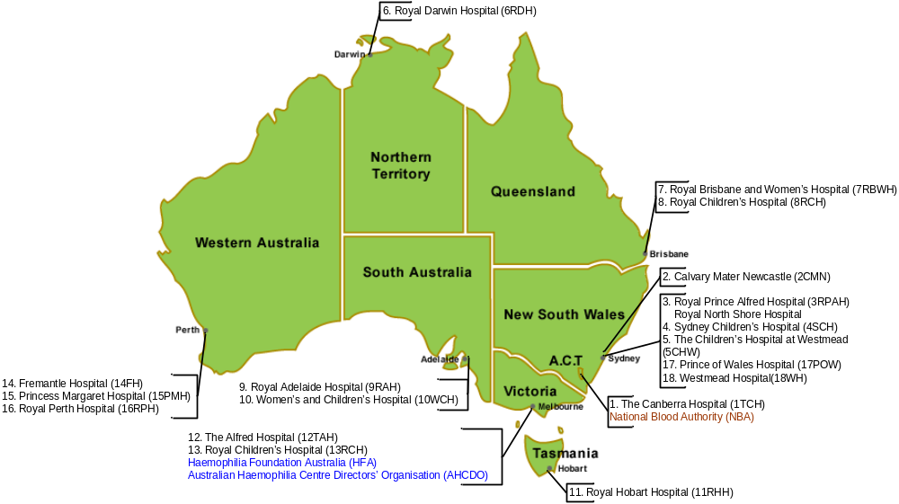

What is the ABDR?
The Australian Bleeding Disorders Registry (ABDR) is a database that is designed to collect all clinical information related to the treatment of people with bleeding disorders. This includes information about patient diagnosis, including viral status, treatment details, hospital admissions and administrative information as well as details on ordering, supply and use of clotting factor products. Information is entered into the ABDR web enabled software by staff at HTCs. The current version of the ABDR has been in existence since December 2008 and background on the development of the system is at Appendix B.

ABDR Management and Governance
The ABDR is managed on a day to day basis by the NBA in accordance with the guidance and policy oversight provided by the ABDR Steering Committee. The Committee consists of representatives of the key stakeholders involved in the clinical management, advocacy and funding of treatment for people with bleeding disorders. In 2009/10 the Steering Committee representatives were:
- Dr John Rowell – Chair – representative of Australian Haemophilia Centre Directors’ Organisation (AHCDO)
- Dr Chris Barnes – Chair, Australian Haemophilia Centre Directors’ Organisation (AHCDO)
- Ms Sharon Caris – Executive Director, Haemophilia Foundation Australia (HFA)
- Mr Geoff Simon, Queensland Health – Jurisdictional Blood Committee nominee
- Ms Stephanie Gunn – Deputy General Manager, National Blood Authority

Accessing the data
Patient confidentiality is paramount with personal data available only to the individual treating HTC and levels of authorisation/access determined by the interaction of staff with individual patients. National reporting is with aggregate, de-identified, data. All use of data, and discussion about the system, other than within the individual HTC, is considered by the ABDR Steering Committee.
The database provides a capability for all HTC staff to enter data on the interactions with patients to provide treating clinicians with a comprehensive picture of the health and wellbeing of patients. The database provides for both real time ordering of product and retrospective collection of data to provide national factor usage data to inform and assist planning and funding. Future development of the system will provide for inclusion of information on physiotherapy and social work interactions with patients.
To ensure appropriate management of the information, the NBA has instigated a detailed governance framework for a data analyst to use a Business Intelligence tool to store and access the de-identified data. This tool is called Big Red. It includes data marts for the Integrated Data Management System (IDMS – which records products issued by suppliers) and the ABDR. Big Red can provide fixed reports and ad hoc queries.

Data quality issues
There are a number of data quality issues in the ABDR. These include incomplete records with missing fields or “not stated” entries. As the system is still relatively young, the data in some fields is also characterised by a lack of consistency in the interpretation of specific fields. These caveats are highlighted on specific tables. The Steering Committee has initiated strategies to improve the data quality and over time the reporting from the ABDR will become more robust.

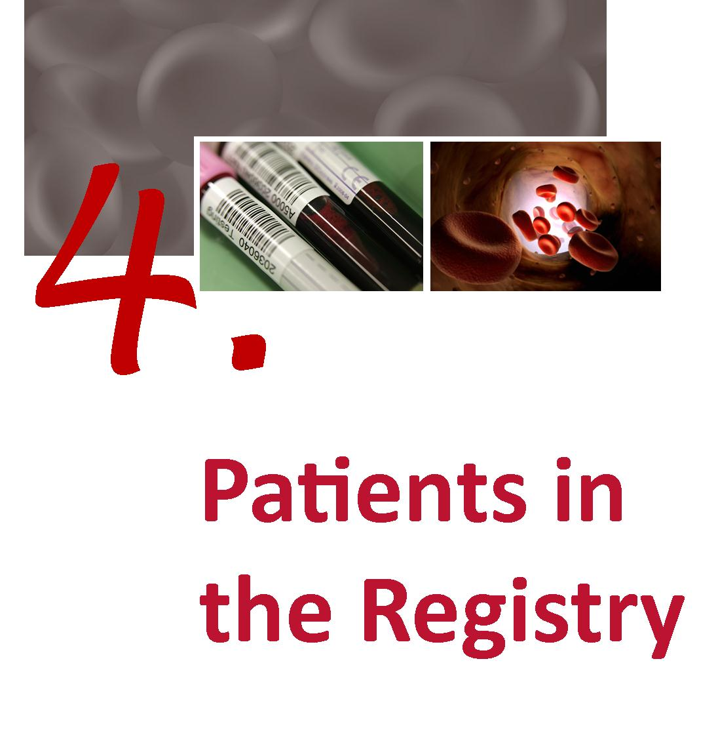

Patients in the Registry
This section of the report presents the key patient data collected by the ABDR. The determination of when a person is in the register is based on their record creation date. Where another data field implied an earlier creation date the earlier date was used.

By diagnosis
Table 3 Number of people in the register and treated by latest broad diagnosis
 | In register at 30 Jun 2009 | Number who received product in 2008-09 | In register at 30 Jun 2010 | Number who received product in in 2009-10
HmA† | 1836 | 690 | 1927 | 830
HmB† | 443 | 152 | 463 | 185
vWD | 1608 | 100 | 1748 | 183
Other Factor Deficiency | 208 | 18 | 229 | 18
Platelet Disorder | 145 | 1 | 154 | 4
Vascular | 4 | 0 | 4 | 0
Other | 35 | 2 | 40 | 0
Not Specified | 112 | 2 | 115 | 0
Grand Total | 4391 | 965 | 4680 | 1220
Note: † Includes some female carriers who are symptomatic

Table 3 confirms that Haemophilia A, von Willebrand disease and Haemophilia B are the most common disorders. Proportionally more Haemophilia A and Haemophilia B patients receive treatment. vWD is typically a mild disorder and data collected within the ABDR represents only a proportion of the total population affected with vWD. In addition, data on carriers is not complete and may not be recorded correctly.
These figures demonstrate a growth in the number of people receiving treatment with the total increasing from 965 in 2008-09 to 1220 in 2009-10.

Table 4 Number of people in the register and treated by detailed diagnosis HmA, HmB and vWD
 | In register at 30 Jun 2009 | Number who received product in 2008-09 | In register at 30 Jun 2010 | Number who received product in in 2009-10
Factor VIII Deficiency (Haemophilia A) | 1581 | 677 | 1649 | 807
Asymptomatic Carrier Factor VIII Deficiency (Haemophilia A)† | 231 | 7 | 246 | 14
Acquired Factor VIII Inhibitor (Acquired Haemophilia A) | 24 | 6 | 32 | 9
Factor IX Deficiency (Haemophilia B) | 388 | 150 | 401 | 176
Asymptomatic Carrier Factor IX Deficiency (Haemophilia B) † | 55 | 2 | 62 | 9
von Willebrand Disease‡ - Uncharacterised | 411 | 8 | 437 | 20
von Willebrand Disease Type 1 | 897 | 32 | 986 | 77
von Willebrand Disease Type 2 - Uncharacterised | 88 | 7 | 96 | 18
von Willebrand Disease Type 2A | 59 | 11 | 60 | 15
von Willebrand Disease Type 2B | 39 | 6 | 42 | 11
von Willebrand Disease Type 2M | 55 | 12 | 66 | 11
von Willebrand Disease Type 2N | 15 | 2 | 16 | 2
von Willebrand Disease Type 3 | 37 | 18 | 38 | 25
Acquired von Willebrand Factor Disease | 7 | 4 | 7 | 4
Grand Total | 3887 | 942 | 4138 | 1198
Notes: † The practice of applying definitions does at this stage vary between HTCs and future work will focus on ensuring consistent approaches are used.
It is rare for asymptomatic carriers to require product. They do not get spontaneous haemorrhages, but may need product support in times of major trauma, surgery or at parturition.
‡ Not all with von Willebrand disease are treated through HTCs and these figures therefore do not represent the total number of vWD patients in Australia. Note also that the specific classification of vWD is incomplete in the ABDR at this stage.

Table 5 Number of people in the register and treated by diagnosis of “other disorders”
 | In register at 30 Jun 2009 | Number who received product in 2008-09 | In register at 30 Jun 2010 | Number who received product in in 2009-10
Factor V Deficiency | 11 | 2 | 13 | 1
Factor VII Deficiency | 47 | 6 | 48 | 6
Factor X Deficiency | 9 | 2 | 10 | 1
Factor XI Deficiency | 110 | 3 | 126 | 3
Factor XIII Deficiency | 16 | 5 | 16 | 7
Fibrinogen - Afibrinogenemia | 4 | 2 | 5 | 0
Fibrinogen - Dysfibrinogenemia | 6 | 0 | 7 | 0
Fibrinogen - Hypofibrinogenemia | 2 | 0 | 2 | 0
Fibrinogen Dysfunction - Uncharacterised | 0 | 0 | 1 | 0
Vascular disorders - Ehlers Danlos Syndrome | 4 | 0 | 4 | 0
Other (Please specify)† | 112 | 2 | 115 | 0
Unknown† | 23 | 0 | 25 | 0
Total | 344 | 22 | 372 | 18
Note: † This represents incomplete data which will be addressed for the next year’s report.
Those with fibrinogen disorders may have been treated with the only funded source of fibrinogen – cryoprecipitate which is not routinely collected within the ABDR.
Table 4 and Table 5 indicate that the growth in numbers of people registered in the ABDR is consistent with the historical proportion of this group of patients to the overall Australian population. This proportion and the growth is largely consistent with that illustrated in the United Kingdom Haemophilia Centre Doctors' Organisation (UKHCDO) annual report. Both show a growth in the year of about 5 per cent. It is expected that with further improvements in data quality, these comparisons will be made with greater confidence.

Table 6 Number in register and receiving product by diagnosis of “Platelet disorders”
 | In register at 30 Jun 2009 | Number who received product in 2008-09 | In register at 30 Jun 2010 | Number who received product in in 2009-10
Platelet - Bernard-Soulier | 1 | 0 | 1 | 0
Platelet - Glanzmann's Thrombasthenia | 6 | 0 | 7 | 2
Platelet - May Hegglin | 3 | 0 | 3 | 0
Platelet - Storage Pool (Dense Granule) Deficiency | 7 | 0 | 11 | 0
Platelet – Uncharacterised† | 128 | 1 | 132 | 2
Total | 145 | 1 | 154 | 4
Notes: † This represents incomplete data which will be addressed for the next year’s report.
Platelet disorders may be treated with DDAVP, platelet infusion (not routinely collected in the ABDR) or rVIIa (collected within the ABDR).
Table 6 shows that data on platelet disorders is not heavily recorded in the ABDR. These disorders tend to be under reported and are typically treated at facilities outside the HTC framework and will, therefore, not necessarily be recorded in the ABDR. Nevertheless, this field will be more value when clear definitions are applied to those patients currently recorded in the ABDR as uncharacterised and this will be a priority for future work.
Table 7 People in the register at 30 Jun 2010 by broad age group, diagnosis and severity
 | Paediatric 0–19 years |  | Adult 20 years and over |  | Total
 | In register at 30 Jun 2010 | Number receiving product in 2009-10 | In register at 30 Jun 2010 | Number receiving product in 2009-10 | In register at 30 Jun 2010 | Number receiving product in 2009-10
HmA† | 550 | 330 | 1377 | 500 | 1927 | 830
Severe | 262 | 232 | 322 | 257 | 584 | 489
Moderate | 76 | 48 | 172 | 80 | 248 | 128
Mild | 204 | 49 | 776 | 153 | 980 | 202
Not Applicable‡ |  |  | 19 | 2 | 19 | 2
Unknown | 8 | 1 | 88 | 8 | 96 | 9
HmB† | 120 | 63 | 343 | 122 | 463 | 185
Severe | 43 | 37 | 45 | 35 | 88 | 72
Moderate | 27 | 17 | 74 | 35 | 101 | 52
Mild | 47 | 8 | 206 | 52 | 253 | 60
Not Applicable‡ |  |  | 3 | 0 | 3 | 0
Unknown | 3 | 1 | 15 | 0 | 18 | 1
vWD | 407 | 38 | 1341 | 145 | 1748 | 183
Grand Total | 1077 | 431 | 3061 | 767 | 4138 | 1198
Note: Mild cases of HmA, HmB and vWD are often treated with DDAVP and the use of this product may not be recorded in the ADBR.
† Includes some female carriers.
‡ Not applicable – may represent data input inconsistencies or incomplete data, and will be addressed for next year’s report.
Unknown represent patients not yet classified or symptomatic carriers not classified.
Table 7 illustrates that a higher proportion of paediatric patients with HmA receive product than do adults and that this difference is less marked for patients with HmB.

Figure 2 Age distribution of people in the ABDR by diagnosis at 30 June 2010
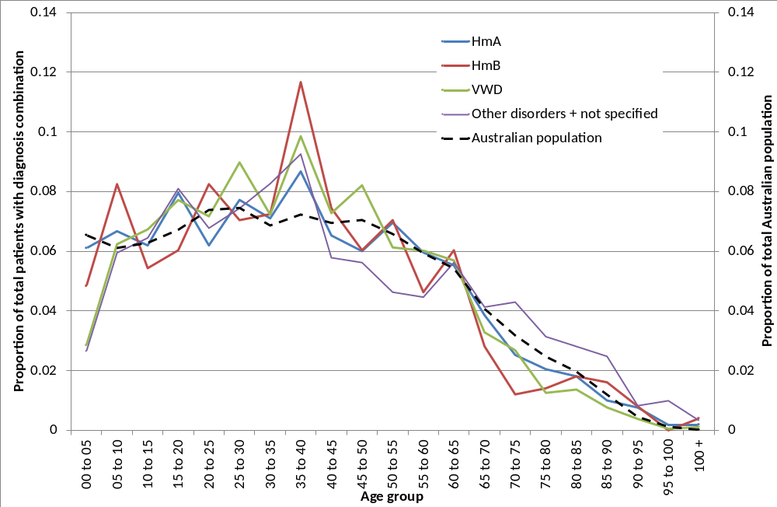

Figure 2 illustrates that the proportion of patients with all disorders currently aged between 35-40 is higher than the proportion of the Australian population at that age group. Notably the proportion of patients aged 5-10 with HmB and those aged between 15-20 with HmA are also substantially higher than the proportion of the Australian population at that age. However, the proportion of patients aged between 60 and 80 with all traditional forms of bleeding disorders is substantially lower than that for the rest of the population. The proportion with other bleeding disorders which are more typically associated with aging and associated medical treatments is the reverse of this picture.

Table 8 von Willebrand Disease in the register at 30 Jun 2010 by broad age group and vWD classification
 | Paediatric 0–19 years |  | Adult 20 years and over |  | Total
 | In register at 30 Jun 2010 | Number receiving product 2009-10 | In register at 30 Jun 2010 | Number receiving product 2009-10 | In register at 30 Jun 2010 | Number receiving product 2009-10
von Willebrand Disease Type 1 | 214 | 9 | 772 | 68 | 986 | 77
von Willebrand Disease Type 2A | 10 | 0 | 50 | 15 | 60 | 15
von Willebrand Disease Type 2B | 9 | 2 | 33 | 9 | 42 | 11
von Willebrand Disease Type 2 - Uncharacterised | 34 | 7 | 62 | 11 | 96 | 18
von Willebrand Disease Type 2M | 24 | 5 | 42 | 6 | 66 | 11
von Willebrand Disease Type 2N |  |  | 16 | 2 | 16 | 2
von Willebrand Disease Type 3 | 10 | 5 | 28 | 20 | 38 | 25
Acquired von Willebrand Factor Disease |  |  | 7 | 4 | 7 | 4
von Willebrand Disease - Uncharacterised | 106 | 10 | 331 | 10 | 437 | 20
Grand Total | 407 | 38 | 1341 | 145 | 1748 | 183

While vWD is typically a mild disorder and data collected within the ABDR represents only a proportion of the total population affected with vWD. This data will be interesting to track over time as there is now an increased awareness of this disease and it is often diagnosed during surgical interventions. As the population ages and seeks more medical intervention, this disease may become more heavily reported. If they receive plasma derived von Willebrand factor they must be included in the ABDR.

Table 9 Comparison of the proportion of patients in the register and treated, UK and Australia, major diagnoses 2010
 | Female |  |  | Male
 | In Register 2009-10 | Treated 2009-10 | Proportion treated | In Register 2009-10 | Treated 2009-10 | Proportion treated
Australia
HmA (Symp + Asymp) | 294 | 25 | 8.5% | 1631 | 805 | 49.4%
HmB (Symp + Asymp) | 80 | 15 | 18.8% | 383 | 170 | 44.4%
vWD | 1003 | 96 | 9.6% | 745 | 87 | 11.7%
Other conditions | 278 | 9 | 3.2% | 264 | 13 | 4.9%
UK
HmA (Symp + Asymp) | 1082 | 53 | 4.9% | 5346 | 2863 | 53.6%
HmB (Symp + Asymp) | 332 | 37 | 11.1% | 1125 | 618 | 54.9%
vWD | 5588 | 620 | 11.1% | 3268 | 363 | 11.1%

The UK population is approximately three times that of Australia. The treatment rates shown in Table 9 are comparable between Australia and the UK although on current data, the proportion of Australian HmB patients receiving product does appear to lower. The incidence of most conditions seems higher in the UK than Australia.

By geography
Figure 3 Distribution of severe Haemophilia A patients by HTC by year
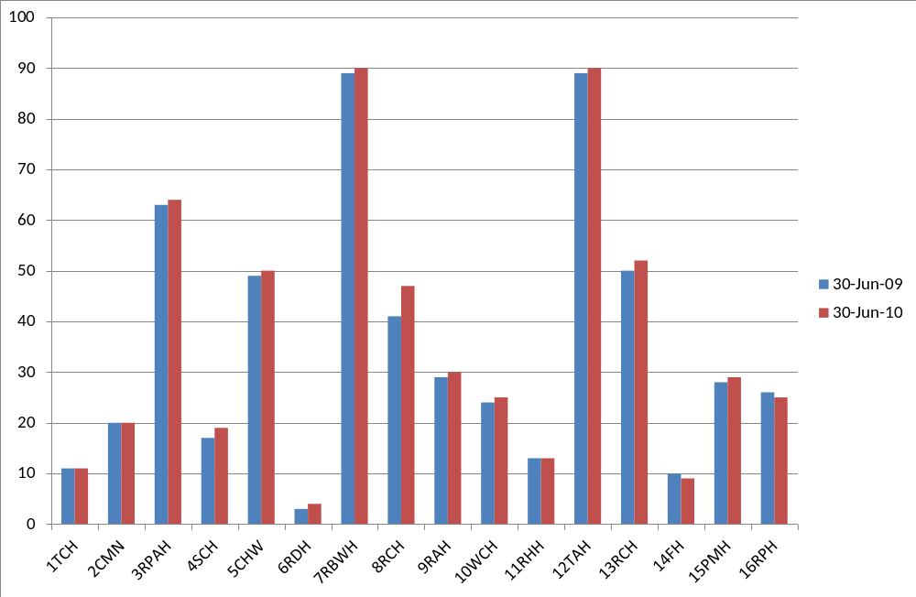
Figure 4 Distribution of severe Haemophilia B patients by HTC by year
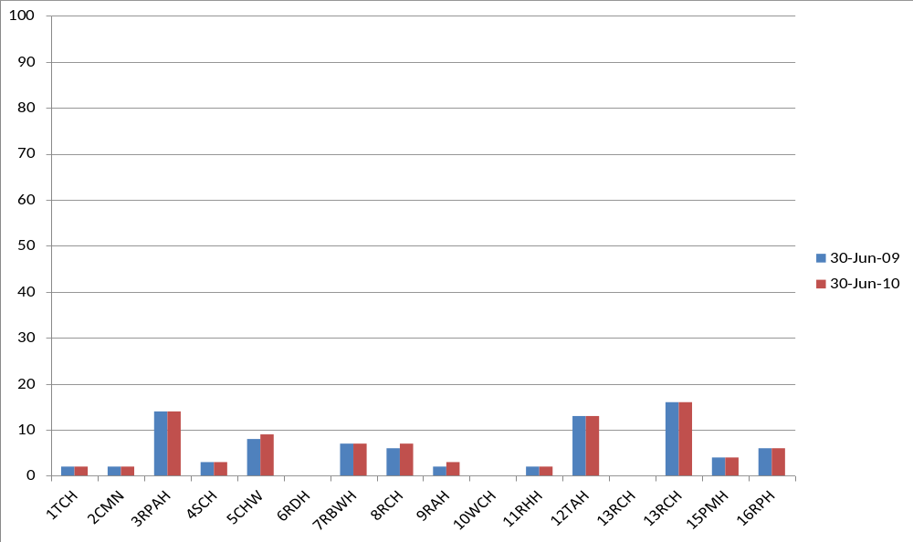
The figures above illustrate variability in the numbers of severe patients registered in each HTC mainly reflecting their catchment size and modest growth in numbers of severe patients numbers over time.
Figure 5 People in the register at 30 June 2010 with Haemophilia A or Haemophilia B by severity and home state (grouping small states)
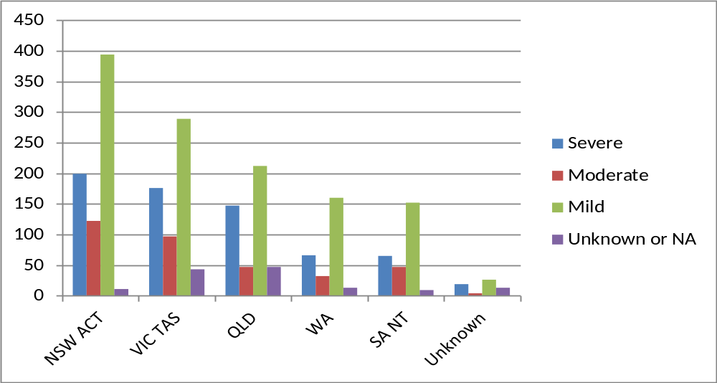
Figure 5 illustrates that numbers of patients with haemophilia are largely consistent with population size. Unknown includes patients who may be temporally overseas and patients who have less severe conditions and have not had recent contact with their HTC.

Incidence of major disorders
Table 10 shows that Haemophilia A in males has the highest incidence with nearly 15 per 100,000 males. The next highest incidence is for von Willebrand disease in females at nearly 9 per 100,000.
Table 10 Incidence of major disorders in Australia people with haemophilia per 100,000 of relevant population
 | Female |  | Male |  | Persons
 | In register at 30 Jun 2009 | In register at 30 Jun 2010 | In register at 30 Jun 2009 | In register at 30 Jun 2010 | In register at 30 Jun 2009 | In register at 30 Jun 2010
HmA all | 2.4 | 2.6 | 14.4 | 14.7 | 8.4 | 8.6
HmA Severe | 0.1 | 0.1 | 5.1 | 5.1 | 2.6 | 2.6
HmB all | 0.6 | 0.7 | 3.4 | 3.4 | 2.0 | 2.1
vWD all | 8.3 | 8.9 | 6.3 | 6.7 | 7.3 | 7.8

The numbers in Table 10 are calculated by dividing the number of people in the register at the date with the broad diagnoses by the total corresponding Australian estimates population at the same date and multiplying by 100,000.
Table 11 Incidence of bleeding disorders selected countries 2008 (per 100,000)
Country | Population | B1. Number of PWH (HmA or HmB) | B2. Number of people with vWD | B3. Number of people with OBD | Number of PWH per 100,000 | Number of people with vWD per 100,000 | Number of people with OBD per 100,000
Australia | 21,262,641 | 1,760 | 1,308 | 629 | 8.3 | 6.2 | 3.0
France | 64,057,792 | 4,779 | 272 | 215 | 7.5 | 0.4 | 0.3
Germany | 82,329,758 | 4,000 | 745 |  | 4.9 | 0.9 | 0.0
Netherlands | 16,715,999 | 1,452 | 263 | 64 | 8.7 | 1.6 | 0.4
Spain | 40,525,002 | 1,932 | 690 | 199 | 4.8 | 1.7 | 0.5
Sweden | 9,059,651 | 1,017 | 1,523 |  | 11.2 | 16.8 | 0.0
United Kingdom | 61,113,205 | 6,061 | 7,852 | 4,999 | 9.9 | 12.8 | 8.2
United States | 307,212,123 | 16,243 | 11,852 | 1,616 | 5.3 | 3.9 | 0.5
Source: World Federation Hemophilia Report on the annual global survey 2008

Table 12 Incidence of Haemophilia A in males in OECD countries (per 100,000)
Country | 1998 | 1999 | 2000 | 2001 | 2002 | 2003 | 2004 | 2005 | 2006 | Mean
Iceland | 37.7 | NA | NA | 39.4 | NA | 39.3 | 38.1 | 38.5 | NA | 38.6
United Kingdom | 19.0 | 19.4 | 17.4 | 17.6 | NA | 17.2 | NA | 22.6 | 20.7 | 19.1
Netherlands | 15.3 | 16.0 | 15.9 | 17.7 | NA | 17.5 | 18.6 | 18.0 | 18.5 | 17.2
New Zealand | 18.5 | 17.0 | 16.7 | 21.6 | NA | 17.8 | 11.7 | 12.3 | 21.9 | 17.2
Ireland | 12.5 | 16.5 | 17.5 | 16.7 | NA | 16.6 | 17.8 | 18.9 | 18.3 | 16.8
Sweden | 15.5 | 16.2 | 14.9 | NA | NA | 14.9 | 15.0 | NA | NA | 15.3
Switzerland | 14.5 | 13.3 | 14.6 | 11.9 | NA | 12.1 | 13.2 | 12.7 | 14.2 | 13.3
Canada | 11.9 | 13.1 | 12.6 | 12.5 | 12.4 | NA | 14.0 | 14.3 | 14.6 | 13.2
Denmark | 11.8 | 11.8 | 12.5 | 12.4 | NA | 12.6 | 12.1 | 13.1 | NA | 12.3
Czech Republic | 12.2 | 12.2 | 12.2 | NA | NA | NA | NA | NA | NA | 12.2
France | 12.7 | 12.7 | 14.8 | NA | NA | NA | NA | 9.8 | 11.0 | 12.2
Greece | 10.7 | 10.8 | 12.2 | 12.4 | NA | 12.4 | 12.8 | 13.0 | 13.0 | 12.2
Belgium | 10.5 | 11.8 | 12.1 | 12.4 | 12.4 | 12.3 | NA | NA | NA | 11.9
Norway | 11.6 | 11.5 | 11.6 | NA | NA | 11.9 | NA | 12.3 | 12.2 | 11.9
Italy | 9.0 | 12.3 | NA | NA | NA | NA | 13.8 | 13.8 | 9.4 | 11.7
Australia | 10.8 | 10.6 | 10.5 | 10.4 | NA | NA | 8.8 | 12.8 | 13.5 | 11.1
Luxembourg | 10.0 | 9.0 | 13.5 | NA | NA | NA | NA | NA | NA | 10.8
Germany | NA | 13.2 | 9.6 | 9.8 | NA | 10.0 | 10.0 | 10.0 | 10.0 | 10.4
Portugal | 8.7 | 8.7 | 8.7 | 8.6 | NA | 10.3 | 9.6 | 9.6 | 9.7 | 9.2
Finland | NA | NA | NA | NA | NA | 8.6 | NA | 9.0 | 9.1 | 8.9
Spain | 10.9 | 8.5 | 8.5 | 10.0 | NA | 9.7 | 7.6 | 7.6 | 7.6 | 8.8
Austria | NA | 8.4 | 8.4 | NA | NA | 8.7 | 8.7 | NA | NA | 8.5
United States | 7.6 | 7.5 | 7.7 | 7.8 | NA | 7.6 | 7.8 | 7.9 | 8.0 | 7.8
Japan | 5.3 | 5.5 | NA | 5.9 | NA | 6.2 | NA | 6.3 | 6.5 | 5.9
Korea | 4.7 | 5.0 | 5.2 | 5.3 | 5.3 | NA | 5.5 | 5.8 | 5.9 | 5.3
Source: World Federation of Hemophilia – Facts and figures (December 2010)

Table 12 shows that of the OECD countries Australia is placed in the middle for incidence of Haemophilia A.

Table 13 Incidence of Haemophilia A in males in selected countries by severity (per 100,000)
Country | Year | Overall | Severe | Severe as a proportion of overall
Canada | 2008 | 14.3 | 4.3 | 30%
Greece | 1992 | 12.0 | 3.6 | 30%
Italy | 2006 | 9.5 | 4.8 | 51%
Netherlands | 2001 | 11.7 | NA | NA
United Kingdom | 2008 | 21.5 | 7.1 | 33%
United States | 1998 | 10.4 | 4.4 | 42%
Australia – In register (current ABDR at 30 June) | 2010 | 14.7 | 5.1 | 35%
Source: World Federation of Hemophilia – Facts and figures (December 2010); ABDR

Table 13 shows that proportion of severe cases in Australia is broadly comparable to other countries

By age distribution
Figure 6 Age distribution of people in the register at 30 June 2010 by severity
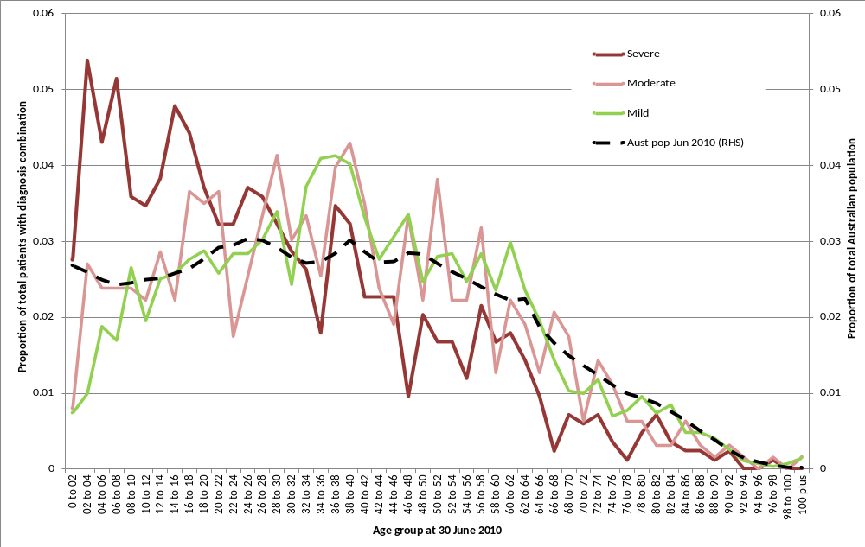
In Figure 6 we see that the age distribution of the severe sufferers is much younger than the other groups and the Australian population as a whole. There is also a dip in the distribution of the severe group around the ages between 40 and 50. The higher proportion at younger ages reflects early diagnosis of the more severely affected.
Figure 7 Age distribution of people in the register at 30 June 2010 with Haemophilia A and Haemophilia B by severity
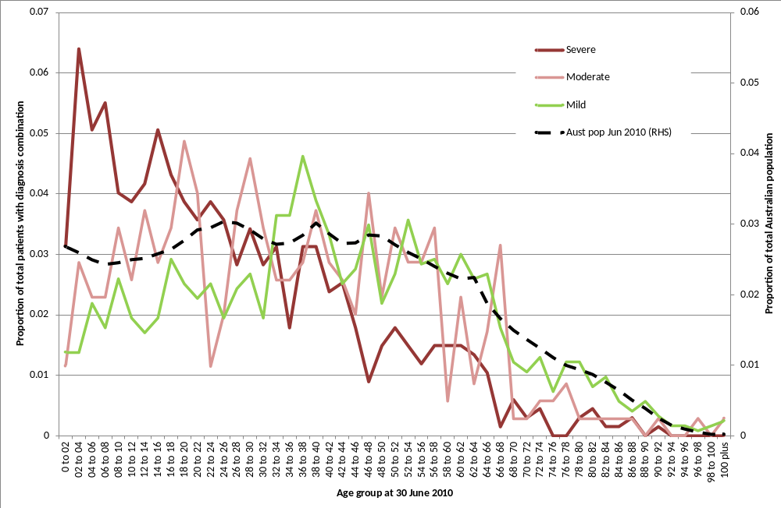

By Inhibitors
Table 14 Number of patients with inhibitors and comparison with UK
 | Severe |  |  | Moderate |  |  | Mild |  |  | Total
 | Inhibitor present | proportion of total with inhibitors | Total Severe | Inhibitor present | proportion of total with inhibitors | Total Moderate | Inhibitor present | proportion of total with inhibitors | Total Mild | proportion of total with inhibitors | Total in Register at 2010
Australia
HmA (Symp + Asymp) | 111 | 19.0% | 584 | 14 | 5.6% | 248 | 25 | 2.6% | 980 | 7.8% | 1927
HmB (Symp + Asymp) | 6 | 6.8% | 88 | 0 | 0.0% | 101 | 0 | 0.0% | 253 | 1.3% | 463
vWD | 2 | 1.7% | 119 | 0 | 0.0% | 225 | 0 | 0.0% | 1184 | 0.2% | 1748
UK
HmA (Symp + Asymp) | 351 | 19.3% | 1814 | 43 | 7.7% | 559 | 62 | 2.1% | 2972 | 8.5% | 5345
HmB (Symp + Asymp) | 15 | 3.8% | 396 | 0 | 0.0% | 244 | 0 | 0.0% | 482 | 1.3% | 1122
vWD | 2 | 1.6% | 125 | 2 | 1.2% | 164 | 0 | 0.0% | 8381 | 0.0% | 8670

Inhibitors are made by the body's immune system to react against replacement clotting factor proteins. This occurs when the immune system perceives the proteins as foreign or harmful to the body. When this happens, the inhibitors prevent the replacement factors from working properly to stop bleeding.
There is some concern at the data entry consistency in this field, however the Australian data appears broadly comparable with the UK data.

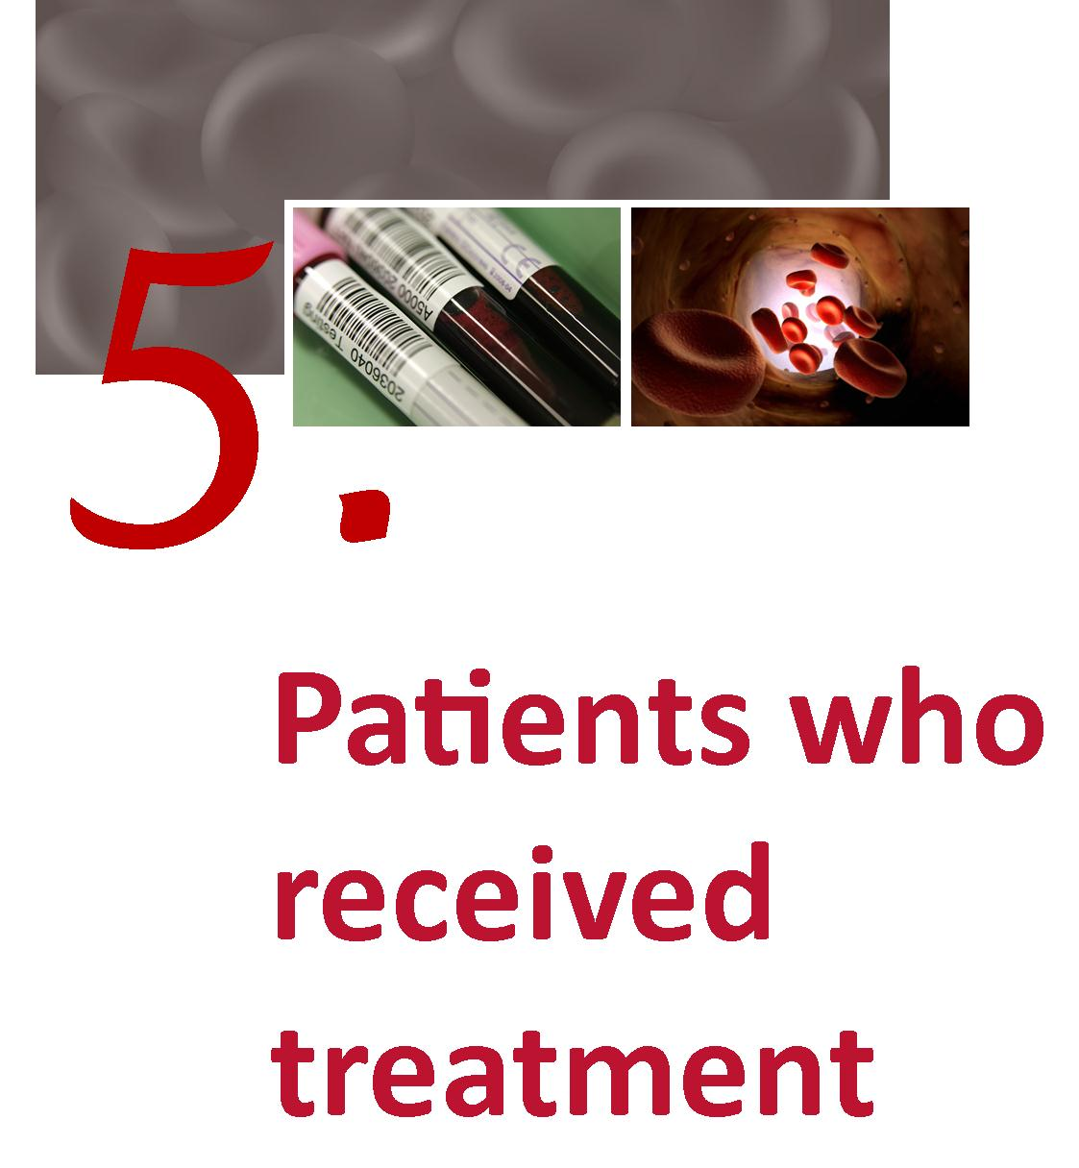

Patients who received treatment
The charts in this are based on the reports of product use in the ABDR and have been collated using the NBA’s Big Red data marts.

By severity
As would be expected, more severe patients are treated more often and receive more product. It is important for supply planning purposes to understand trends in the proportion of patients diagnosed as severe to ensure adequacy of supply and likely demand in the future.
Figure 8 HmA (Symp + Asymp) – Number of patients receiving treatment by severity
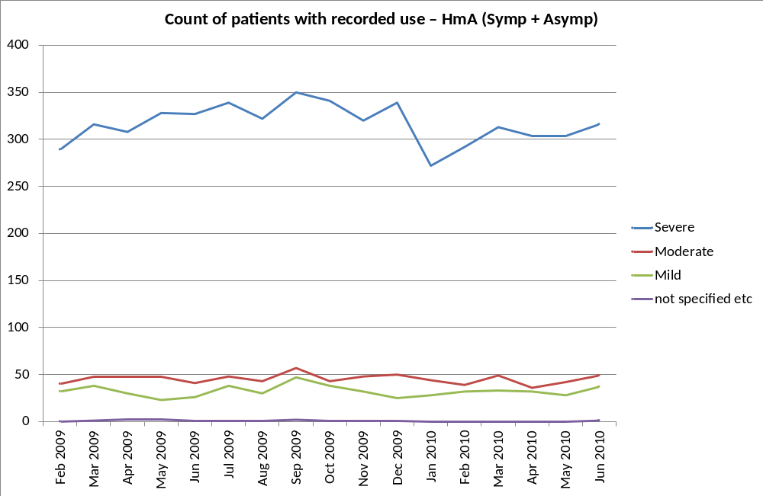
Source: ABDR

Figure 9 HmB (Symp + Asymp) – Number of patients receiving treatment by severity
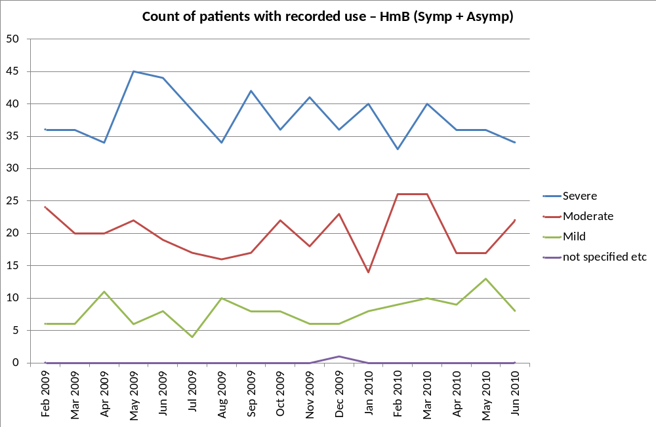
Source: ABDR

Figure 10 vWD – Number of patients receiving treatment by type of vWD
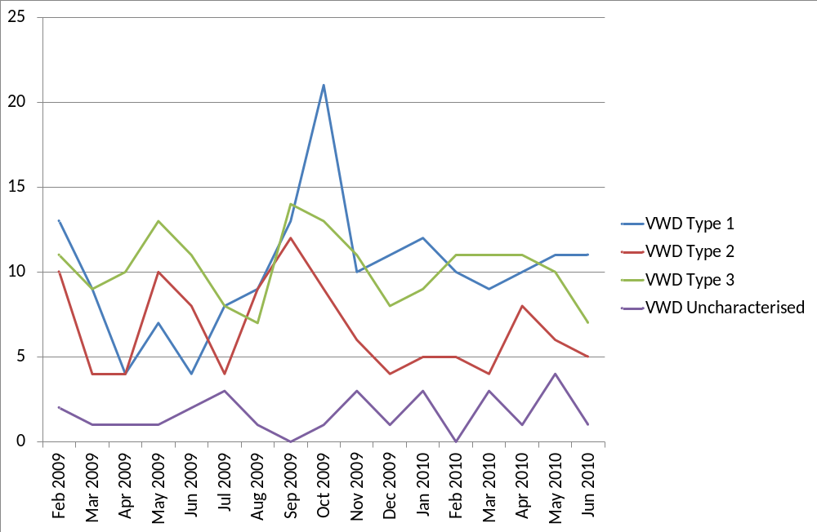
Source: ABDR

As would be expected, a higher proportion of those patients with severe diagnosis, receive treatment during the year although the pattern for patients with vWD is less predictable than other diagnoses as numbers are small. Note that many persons with vWD particularly type 1 will receive DDAVP – use of which is not recorded in the ABDR.
Figure 11 International Units of product received by patients treated by purpose
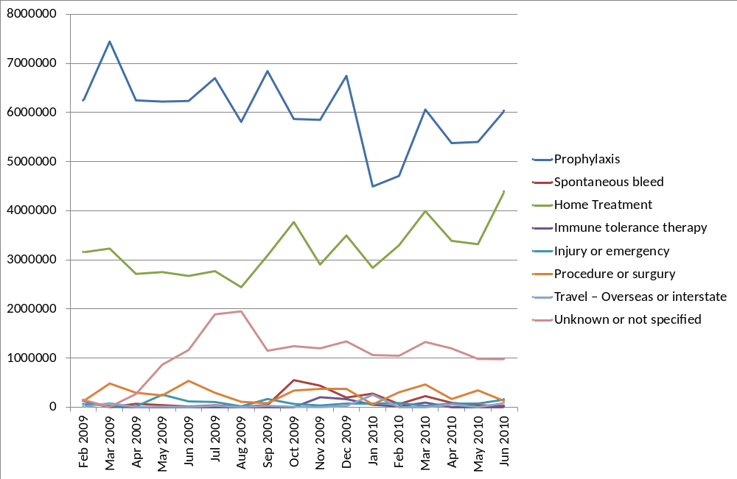
Source: ABDR

This field in the ABDR has been identified as requiring further clarification. The classifications by purpose currently provided are not mutually exclusive and some patients may have been counted more than once. Further, different HTCs or clinicians may interpret them differently. The definitions and data entry protocols will be an area of focus for future work. A likely revamp of this field will be to record this information by:
- Location – home or hospital
- Regimen – prophylaxis or on demand
- Purpose – bleed, surgery, procedure or prevention (prophylaxis)

National average issues of Factor VIII by severity
There are many other factors affecting the use of product including body weight and ranges of severity. Figure 12 shows the average issue of factor VIII by severity by state. The more severe the condition is the greater the amount of product given. Moreover, there is considerable difference between the states. Some of this difference relates, however, to incomplete record of product use at the time of publication and recording use with a not stated product.
Figure 12 Total issues of Factor VIII recorded in the ABDR issued to Haemophilia A patients divided by the number in the register who were treated, by home state of patient and severity in 2009-10
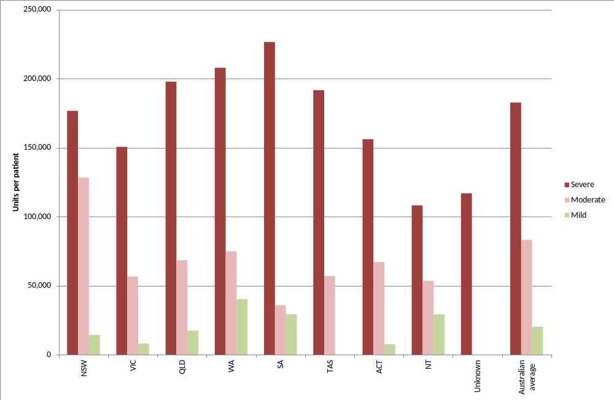
Unknown: Where location, as at the time of reporting, was indeterminate
Figure 13 Median Factor VIII per Haemophilia A patients by state and severity in 2009-10
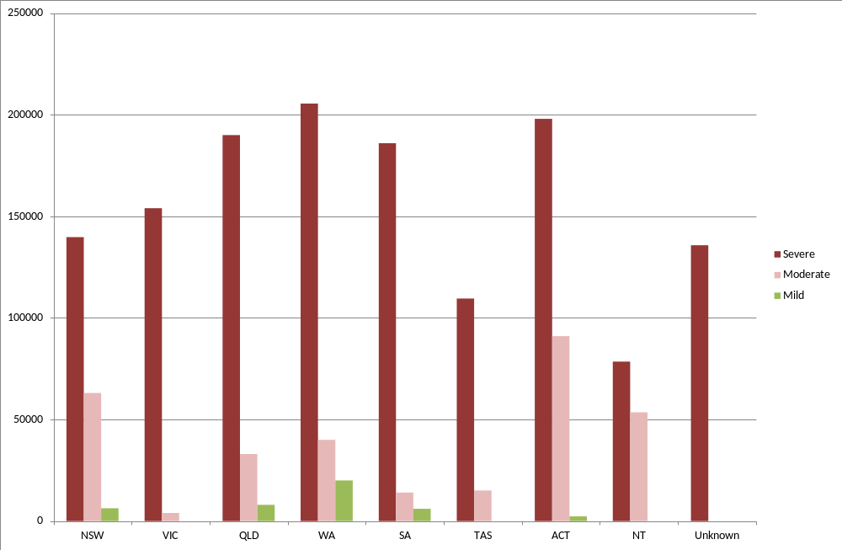
Note: Product that is not fully described is coded as zero which is the reason for some of the zero value for Mild.
Unknown: Where location, as at the time of reporting, was indeterminate

Table 15 Issues of Factor VIII to Haemophilia A patients UK and Australia
 | United Kingdom |  |  | Australia
 | Number treated | Total units of FVIII | Units per patient | Number treated | Total units of FVIII | Units per patient
Severe HmA | 1,596 | 366,276,171 | 229,496 | 489 | 89,335,750 | 182,691
Non severe HmA | 1,111 | 64,812,779 | 58,337 | 341 | 14,940,250 | 43,813
Tot HmA | 2,707 | 431,088,950 | 159,250 | 830 | 104,276,000 | 125,634

By weight and height
Figure 14 Weight and height data for ABDR patients receiving treatment
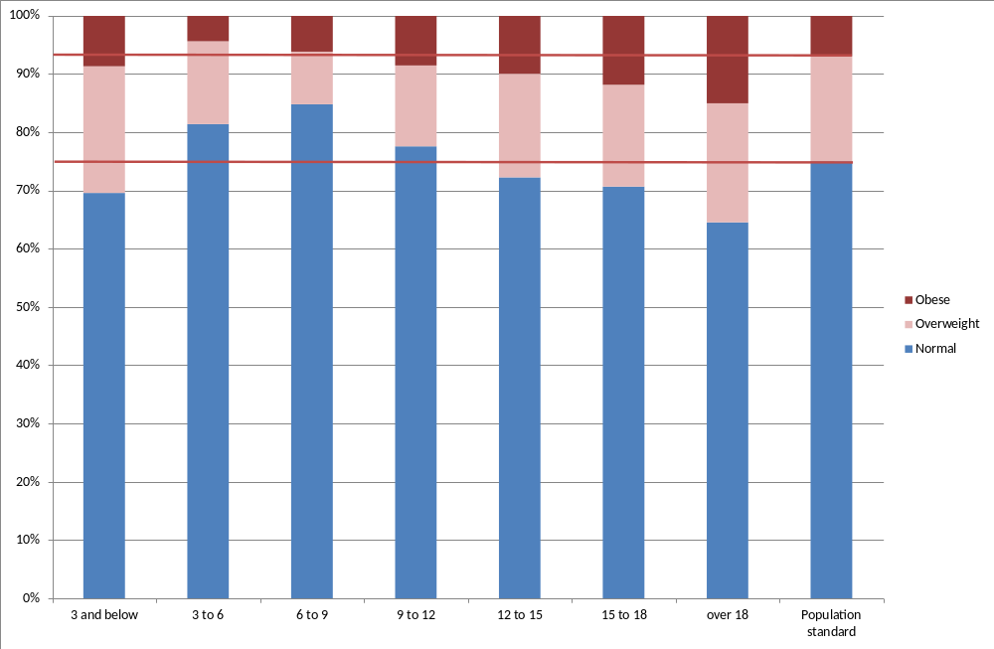
Source: ABDR and Victorian Department of Health

Figure 14 was constructed using age, weight and height data collected in ABDR. These data were combined to calculate the body mass index (BMI). The calculated BMIs were compared with an age appropriate BMI scale produced by Victorian Department of Health to determine whether the BMI corresponded to that person being overweight or obese. Generally 25 per cent of the population are considered overweight and 7 per cent obese. These data may not be fully representative for adult patients as the height and weight data is less complete for them. Nevertheless, as dosage is often related to weight high proportions of overweight and obese patients may lead to an increase in the rate of growth of demand for products.

By age distribution
The following section shows the age distribution of patients who received product in at least one of the last two financial years.
Figure 15 Age distribution of patients who received treatment in 2008-09 or 2009-10 compared with the Australian population
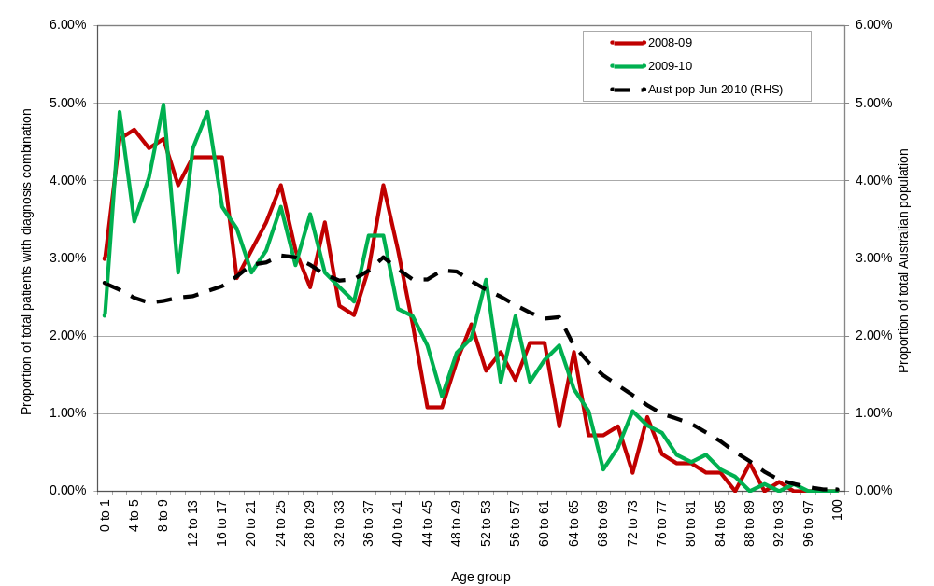
Source: ABDR and ABS Population statistics

Figure 15 shows that those patients in the ABDR who are receiving treatment are generally younger than the Australian population as a whole. Also of note is the dip in the distribution at patients aged around 40 to 45. These distributions are similar to that for patients with severe conditions in Figure 6 and Figure 7.
Figure 16 Age distribution at 30 June 2010 of Haemophilia A and Haemophilia B patients who received product in 2009-10
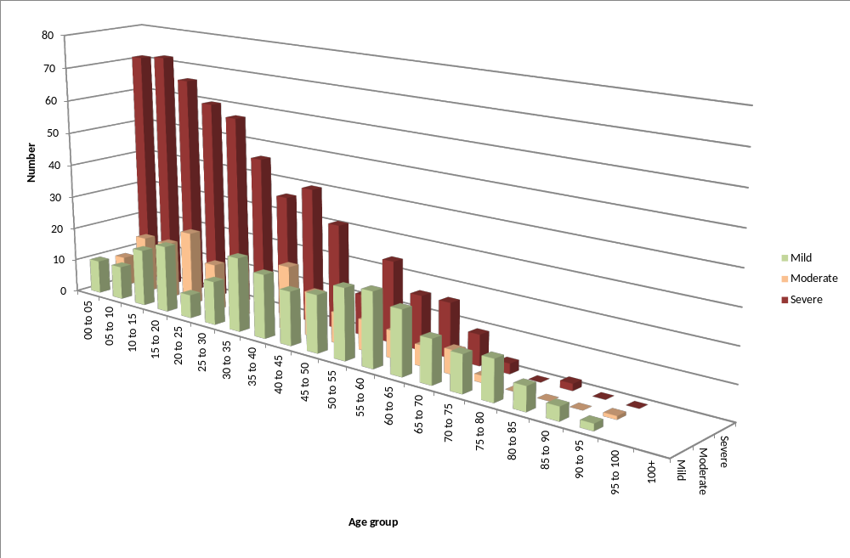
Figure 16 shows a large proportion of the severe Haemophilia A and Haemophilia B population are in the younger age groups. If the higher numbers in the younger age groups flow into older age groups and are replaced, overall demand may grow strongly.

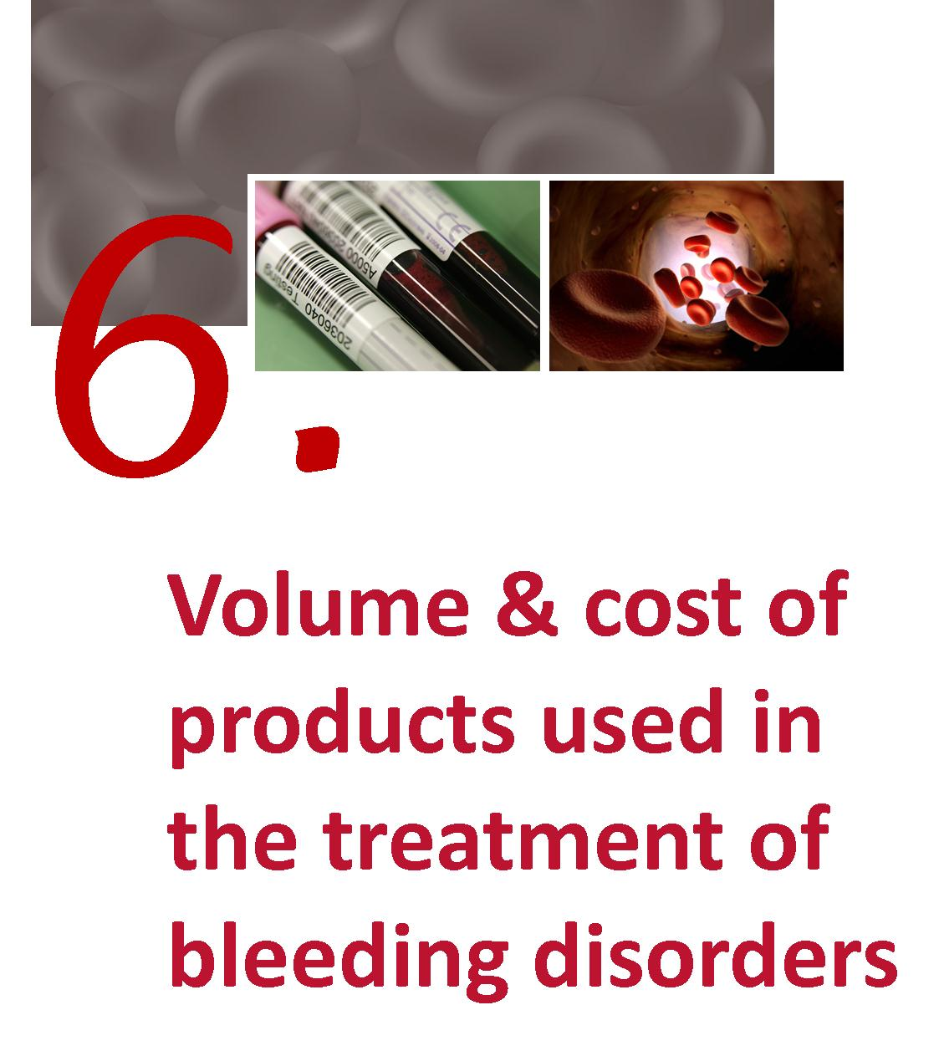

Volume and cost of products used in the treatment of bleeding disorders

National issues by product
Figure 17 shows both the strong growth of clotting factors used in the treatment of haemophilia sufferers and the even stronger growth in the use of recombinant clotting factors.
Figure 17 Annual international units of Factor VIII issued nationally 2003-04 to 2009-10
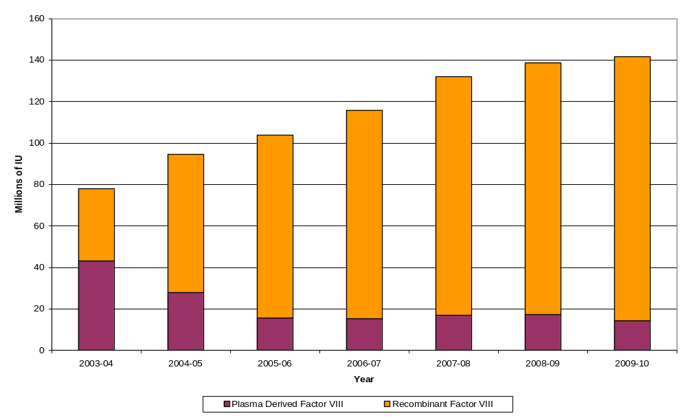
Source: IDMS database of issues

This shows that demand for Factor VIII has increased by 82 per cent over the years (an average rate of 10.4 per cent per annum) but that this growth rate in the last two years has slowed to 2.1 per cent. This figure also illustrates the rapid uptake of recombinant product.
It will be important to monitor this slowing growth rate against the change in age distribution of severe patients depicted at Figure 15 and the model developed at figure 16.
Figure 18 Annual international units of Factor VIII issued nationally per 1000 population 2003-04 to 2009-10
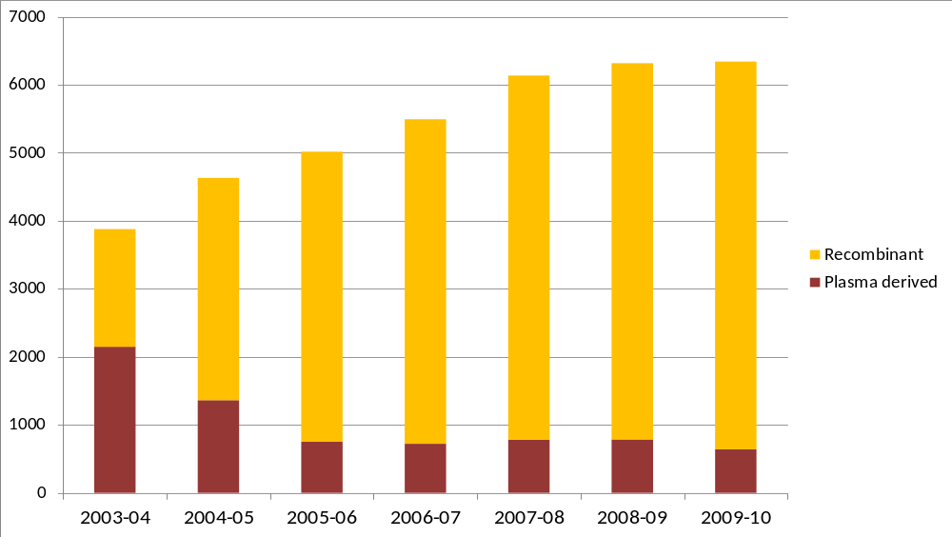
Source: IDMS database of issues.

Figure 19 Annual international units of Factor IX issued nationally 2003-04 to 2009-10
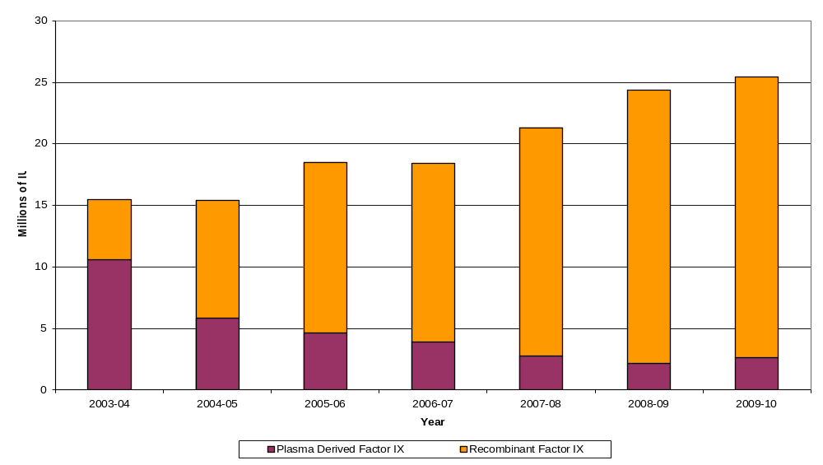
Source: IDMS database of issues.

Similar to Figure 17, Figure 19 shows the strong growth of factor IX use (64.5 per cent or 8.6 per cent per annum) and the substitution of recombinant for plasma derived product.
Figure 20 Annual international units of Factor IX issued nationally per 1000 population 2003-04 to 2009-10
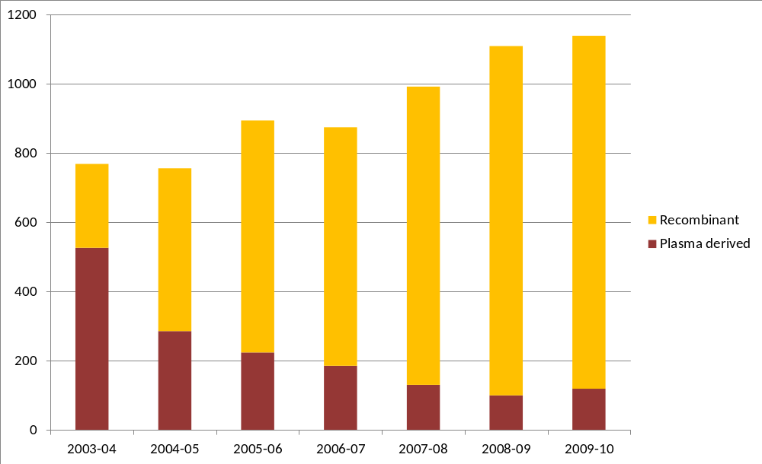
Source: IDMS database of issues.

Figure 21 Annual international units of Factor VIII inhibitor Bypassing Activity (FEIBA) issued nationally 2003-04 to 2009-10
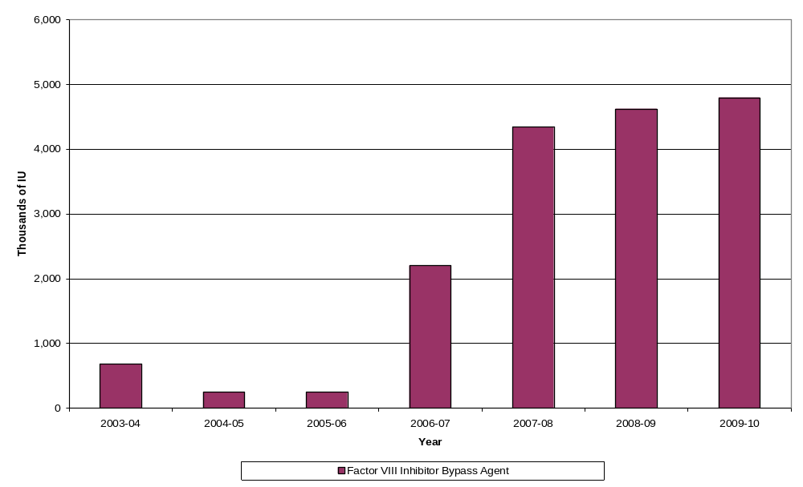
Source: IDMS database of issues.

Figure 22 Annual international units of Factor VIII inhibitor Bypassing Activity (FEIBA) issued nationally per 1000 population 2003-04 to 2009-10
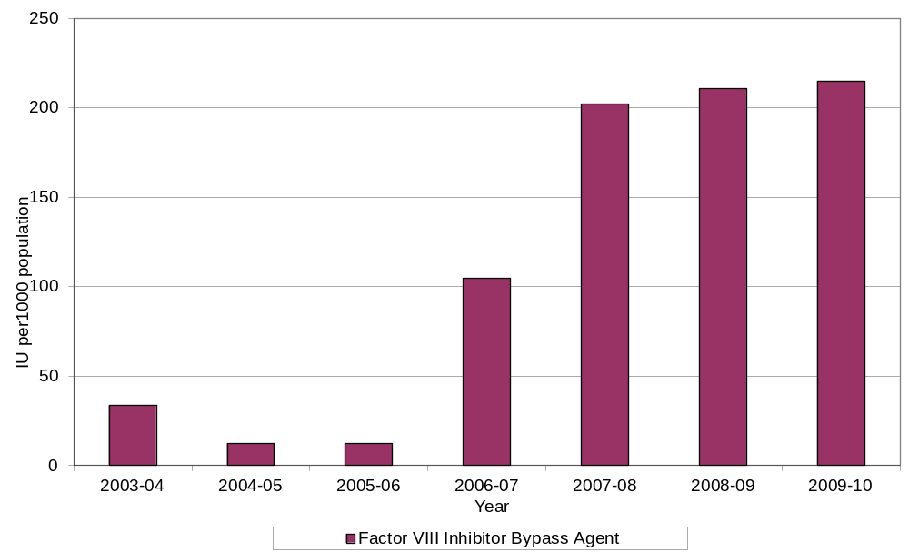
Since 2005-06 demand for FEIBA has increased significantly; in 2005-06 approximately 251,500 IUs were issued compared with almost 4.8 million IUs in 2009-10 (Figure 21). This represents an increase in growth of 775% in 2006-07 over 2005-06, and 97% in 2007-08 over 2006-07, although the growth in demand has slowed to 3.8% in 2009-10. Part of this growth relates to FEIBA becoming more widely available and government funded in 2006-07.
Predicting or interpreting changing demand trends is not possible with any accuracy, as the product is only used in a small number of patients each year. Use patterns will vary from year to year and will not only depend on the number of patients treated, but their severity of disease, the potency of inhibitors, whether secondary prophylaxis is practiced, the number and severity of spontaneous bleeds, and the amount of elective surgery undertaken in this patient group.
FEIBA and recombinant factor VIIa (rVIIa) (brand name NovoSeven) are both used to treat patients that have developed inhibitors.
Drivers for clinical demand for FEIBA are similar to those for NovoSeven when issued under the National funding arrangements. The work of AHCDO in standardising protocols in haemophilia management will likely assist with driving a consistency of approach to the use of FEIBA and similar/related agents.
Figure 23 Annual international units of Recombinant Factor VIIa (NovoSeven) 2003-04 to 2009-10
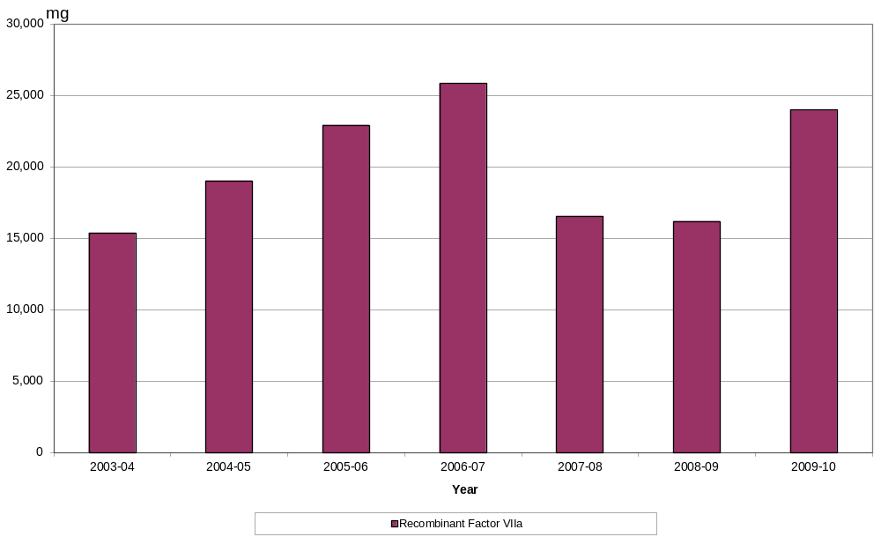
Source: IDMS database of issues.

Figure 24 Annual international units of Recombinant Factor VIIa (NovoSeven) per 1000 population 2003-04 to 2009-10
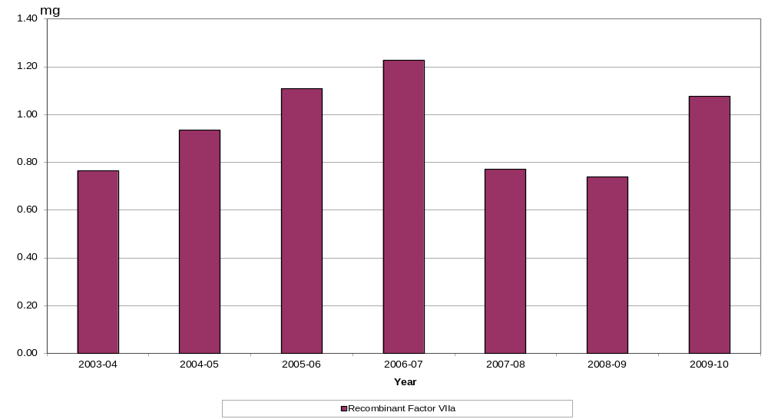
Source: IDMS database of issues.
Demand for NovoSeven to treat patients with haemophilia under the National Blood Arrangements increased sharply from 2003-04 (15,400mg) to a high point in 2006-07 (25,900mg) but then declined to a more stable level in 2007-08 and 2008-09. However, high growth (47%) has been seen again from 2008-09 to 2009-10 (Figure 24). Demand for NovoSeven is very difficult to predict due to small patient numbers and patient specific requirements. At times very large doses can be needed by a single patient.

National Costs for products issued
Total expenditure on clotting factors for 2009/10 was $188.5 million. This was an increase of $14.9 million on 2008/09.
This represents about 24 per cent of the total blood and blood product budget for 2009/10. Expenditure by product is detailed in the NBA Annual Report available at www.nba.gov.au and is summarised below.
Table 16 National clotting factor costs 2008-09 and 2009-10 in $ million
 | 2008-09 | 2009-10
Factor VIII | 104.3 | 109.3
Factor IX | 26.1 | 26.7
Recombinant Factor VIIa | 17.4 | 26.4
FEIBA | 13.5 | 14.5
Other products | 12.3 | 11.5
Total | 173.6 | 188.5

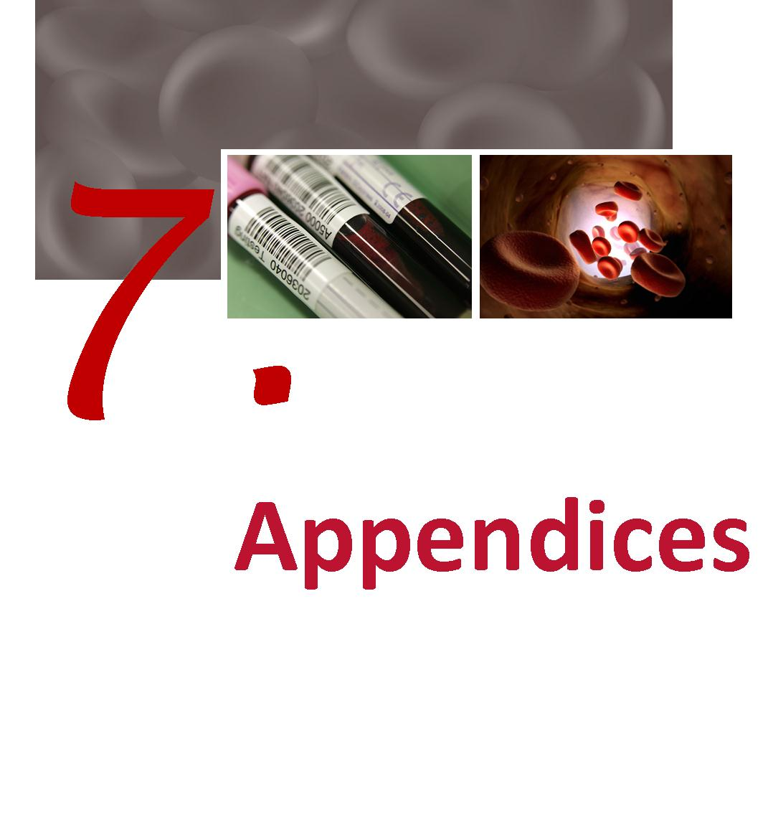

Appendices
Appendix A Haemophilia Treatment Centres
The information at items 1 and 2 below is based on the original statement by the Australian Health Ministers Advisory Council which set out the intended objectives and benefits of the establishment of Haemophilia Treatment Centres (HTC’s). The degree to which existing arrangements directly align to these original objectives varies.
  - The objectives of HTC’s
Haemophilia Treatment Centres should be tasked with the provision of comprehensive care for people with haemophilia. Their roles can include:
- Compilation and distribution of guidelines for best practice directed toward optimal care of patients with disorders of haemostasis
- Providing protocols for the accurate diagnosis of patients with bleeding disorders
- Providing protocols for the regular review of infectious disease markers in patients and their families
- The allocation and distribution of therapeutic blood and recombinant products together with advice regarding the usage of blood and recombinant products, at a State and National level.
- The establishment of review programs to assess outcomes of therapies.
- Provision of regularly updated data to the national Haemophilia Register.
- Participation in basic and clinical research.
  - Operating concept
Haemophilia Centres coordinate and, where possible, integrate patient care, research and education to provide the optimal use of expertise and resources within hospitals and the community. One collaborative centre for each State and Territory may suffice but this must include adult and paediatric type centres.
The role of the Haemophilia Centres is to provide:
- a single point accountability for the care of patients with bleeding disorders with responsibility for the coordination, allocation and distribution of therapeutic resources for the treatment of patients, ie coagulation products derived either from blood donors or recombinant technologies
- a clinical service by experienced staff for persons with bleeding disorders and their families at short notice at any time of the day or night
- organisation of home therapy programs by the centre or in collaboration with other haemophilia treatment facilities.
- a counselling and advisory service for people with haemophilia and their families including genetic counselling and family planning.
- specialist medical expertise, principally haematology, surgery (the surgeons would have to be accredited to the Haemophilia Centre) rheumatology, infectious diseases and dental services.
- specialist allied health services to include physiotherapy, social work and podiatry.
- a laboratory service able to carry out all investigations required for the accurate diagnosis of haemophilia and other inherited disorders of the haemostasis and to have access, in association with other centres, to specialised testing facilities, for example gene typing.
- a system of record for all investigations, treatments, allocation of therapeutic products and adverse reactions.
- a capability to participate in research including clinical trials
- educational programs for medical staff, other personnel, patients and their families which promote care of patients with disorders of haemostasis.
- an outreach service to isolated patients and treating medical services. The outreach service may include:-
- A haemophilia treatment facility located in a hospital that does not provide all the specialist services
- Designated supervising medical practitioner
All isolated patients where care is managed in an outreach program should be registered at and be reviewed regularly by a Haemophilia Centre which would arrange delivery of and monitor the supply of therapeutic coagulation products.

Table 17 List of operational HTCs and their ID codes
# | Hospital | Haemophilia Treatment Centre | ID | State
1 | The Canberra Hospital | Haemophilia Clinic | 1TCH | ACT
2 | Calvary Mater Newcastle | Haemophilia Treatment Centre | 2CMN | NSW
3 | Royal Prince Alfred Hospital | Haemophilia Treatment Centre | 3RPAH | NSW
4 | Sydney Children’s Hospital | Centre for Children's Cancer and Blood Disorders | 4SCH | NSW
5 | The Children’s Hospital at Westmead | Haemophilia Treatment Centre | 5CHW | NSW
6 | Royal Darwin Hospital | Haemophilia Treatment Centre | 6RDH | NT
7 | Royal Brisbane and Women’s Hospital | Queensland Haemophilia Centre | 7RBWH | QLD
8 | Royal Children’s Hospital | Queensland Haemophilia Centre Child and Adolescent Service | 8RCH | QLD
9 | Royal Adelaide Hospital | South Australia Haemophilia Treatment Centre | 9RAH | SA
10 | Women’s and Children’s Hospital | South Australia Haemophilia Treatment Centre | 10WCH | SA
11 | Royal Hobart Hospital | Tasmanian Haemophilia Treatment Centre | 11RHH | TAS
12 | The Alfred Hospital | Ronald Sawyers Haemophilia Centre | 12TAH | VIC
13 | Royal Children’s Hospital | Henry Ekert Haemophilia Treatment Centre | 13RCH | VIC
14 | Fremantle Hospital | The Haemophilia Centre of WA | 14FH | WA
15 | Princess Margaret Hospital | The Haemophilia Centre of WA | 15PMH | WA
16 | Royal Perth Hospital | The Haemophilia Centre of WA | 16RPH | WA
99 | Offshore Patient - Long Term | Offshore Patient - Long Term | 99OPL
98 | Inactive Patients | Inactive Patients | 98DPG

  - Data Quality of HTC data collections
Health professionals at HTCs are represented by:
- Australian Haemophilia Nurses Group (AHNG)
- Australia/New Zealand Haemophilia Social Workers’ and Counsellors’ Group (ANZHSWCG)
- Australia/New Zealand Physiotherapist Group (ANZHPG)
These representatives, along with the HFA have provided input into the initial design of the ABDR and continue to provide input from their respective areas of specialty.
The Data Managers at each HTC have elected Data Manager Co-Chairs. These Co-Chairs coordinate teleconferences, between all Data Managers, on a regular basis. The Data Manager Co-Chairs also have the functionality of raising issues, to the NBA, on behalf of their group. AHCDO has a major role in providing support to ABDR Data Managers through the funded model for Data Managers.
Data Quality initiatives implemented in 2009-10 include:
- Annual Data Manager Conference (In conjunction with HFA Conference)
- Data Manager Training Sessions
- Data Dictionary (a document that contains information about the data)project undertaken by ABDR Data Manager Co-Chairs)
- ABDR reporting suite (developed reports) for Haemophilia Treatment Centre Data Managers
- ‘Advanced Search’ functionality of the ABDR whereby Data Managers are able to extract information from the ABDR on an ad hoc basis to, for example, validate data entry and provide clinical information to HTC clinicians
- NBA financial support, through AHCDO funding, for HTC Data Managers
- The ABDR Newsletter is a functional tool that provides an update on issues such as changes to the ABDR and functionality enhancements. This update is a means of keeping all ABDR stakeholders informed. (Refer Appendix D for example of August 2010 ABDR Newsletter)

Data Manager Training Session – Melbourne 2010
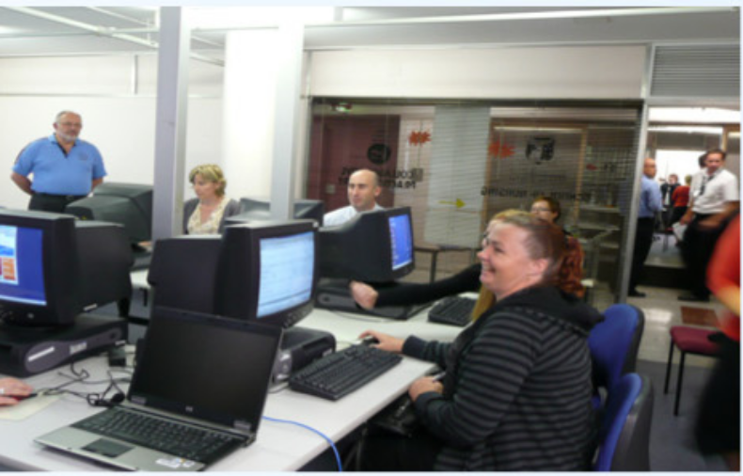

Data Quality initiatives in 2009-10 have addressed:
- Clean up of migrated data
- Currency of data
- Unpopulated data fields
- National consistency of data quality
- Ongoing issues of information exchange when persons with haemophilia (PWH) move between states and haemophilia treatment centres
- Historical data (immediately prior to the deployment of the redeveloped ABDR in December 2008

Appendix B History and development of the ABDR
The ABDR was first established in 1988 using a ‘Paradox’ database at each Haemophilia Treatment Centre in Australia. The aims of the ABDR were to provide a clinical tool for improved management and national demographics of persons with haemophilia and other inherited bleeding disorders.
In 2000, a revised ABDR was established using ‘Access’ database platform at each Haemophilia Treatment Centre with a national collection of de-identified data every six months. Dedicated data base managers in individual centres improved data collection. Ongoing concerns regarding privacy prevented collection of national demographics such as age and gender.
To provide better sharing and access to the database it was decided in 2006 to move to an internet interface to central database. Genix Ventures was the successful tender with the National Blood Authority providing funding and project management.
The redeveloped ABDR was deployed in December 2008 at all HTCs.
  - Benefits of the redeveloped ABDR
The NBA redeveloped the ABDR and deployed the redeveloped ABDR in December 2008. It provides the following benefits:
- Single point of access for clinicians for treatment of patients
- Patient information relating to all clinical information associated with the treatment of haemophilia
- Information exchange between states and Haemophilia Treatment Centres
- National demographic information (age, gender etc) of persons with bleeding disorders
- National data on inhibitor incidence and outcomes of treatment
- Allied health (physiotherapy and social work) monitoring and outcomes
- Recording of personal usage of factor replacement for clinical monitoring
- Data for forward planning and funding of factor concentrates on a national basis
- High usage patterns
  - Current position of the development of the ABDR
Today the Australian Bleeding Disorders Registry is fully operational. The ABDR Steering Committee continues to oversee the project.
The National Blood Authority’s role continues around provision of resources to maintain ABDR operations and to ensure timely and accurate reporting from the ABDR through provision of support to Data Managers. Data Managers, funded and supported by AHCDO, are located at HTCs across Australia.

Appendix C ABDR data collection (registration form)
Appendix D August 2010 ABDR Newsletter
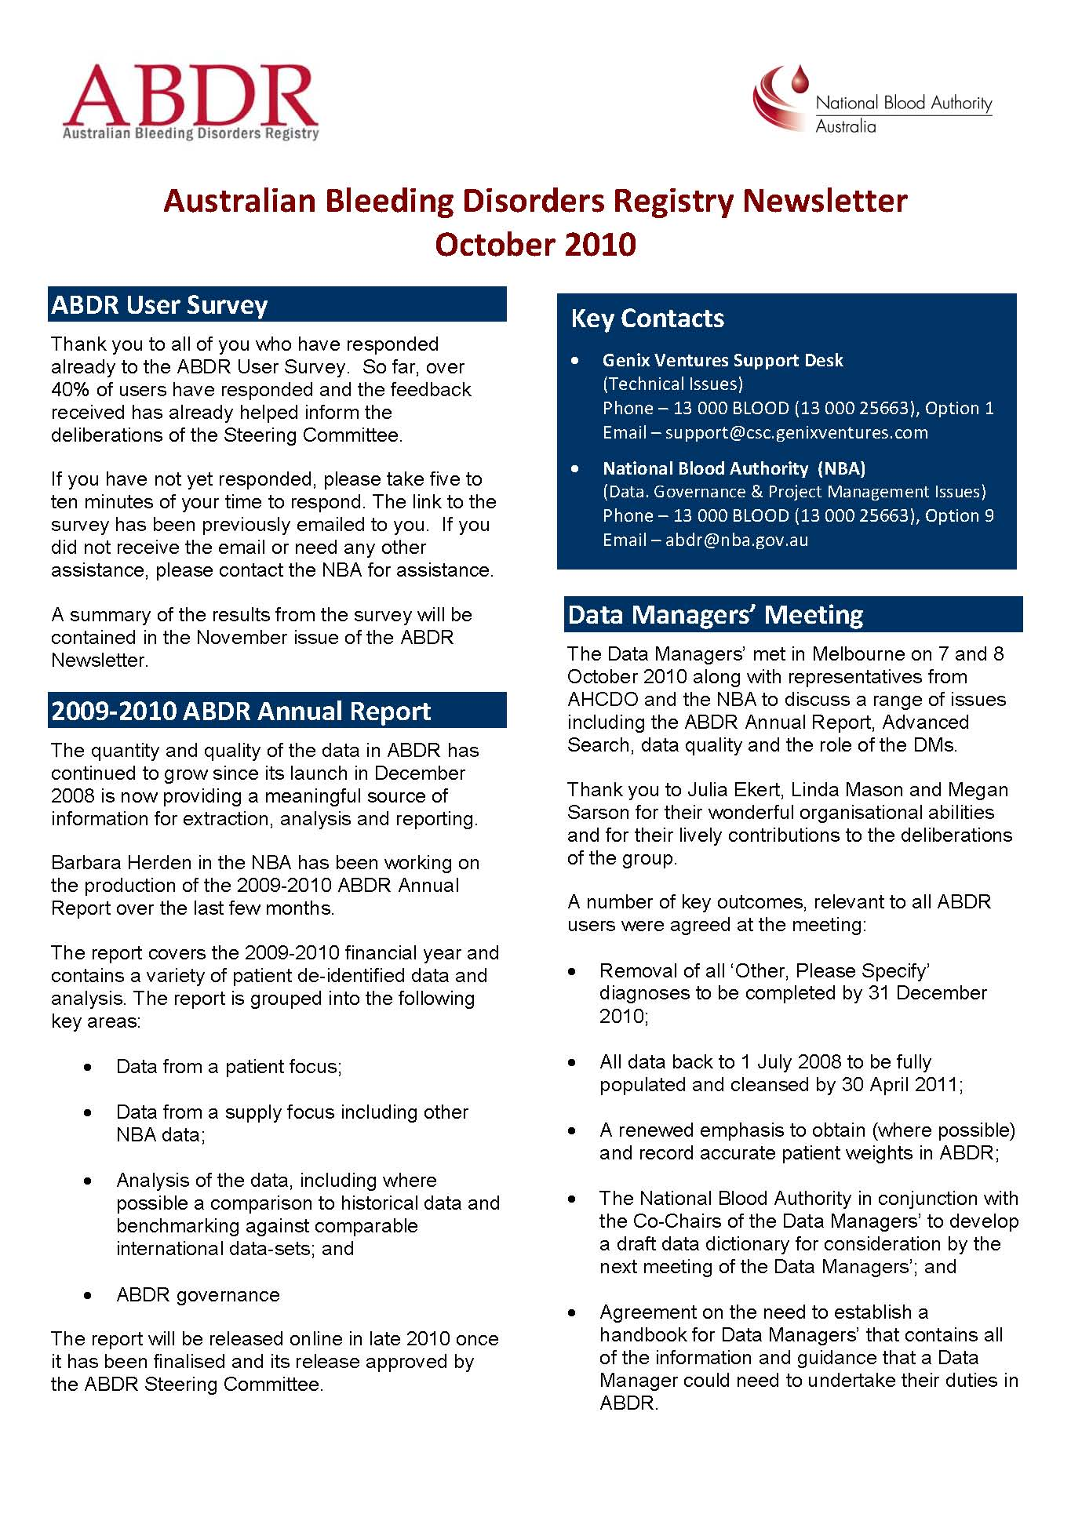
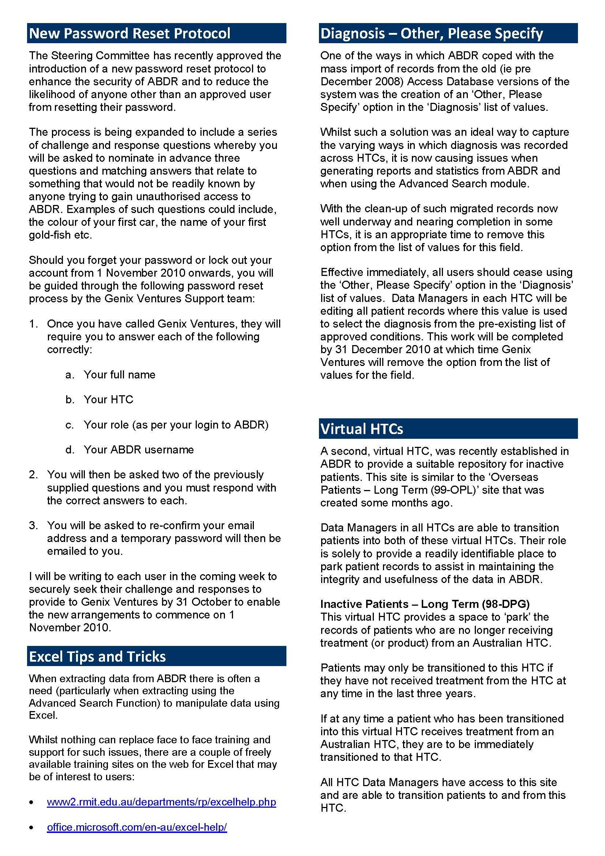
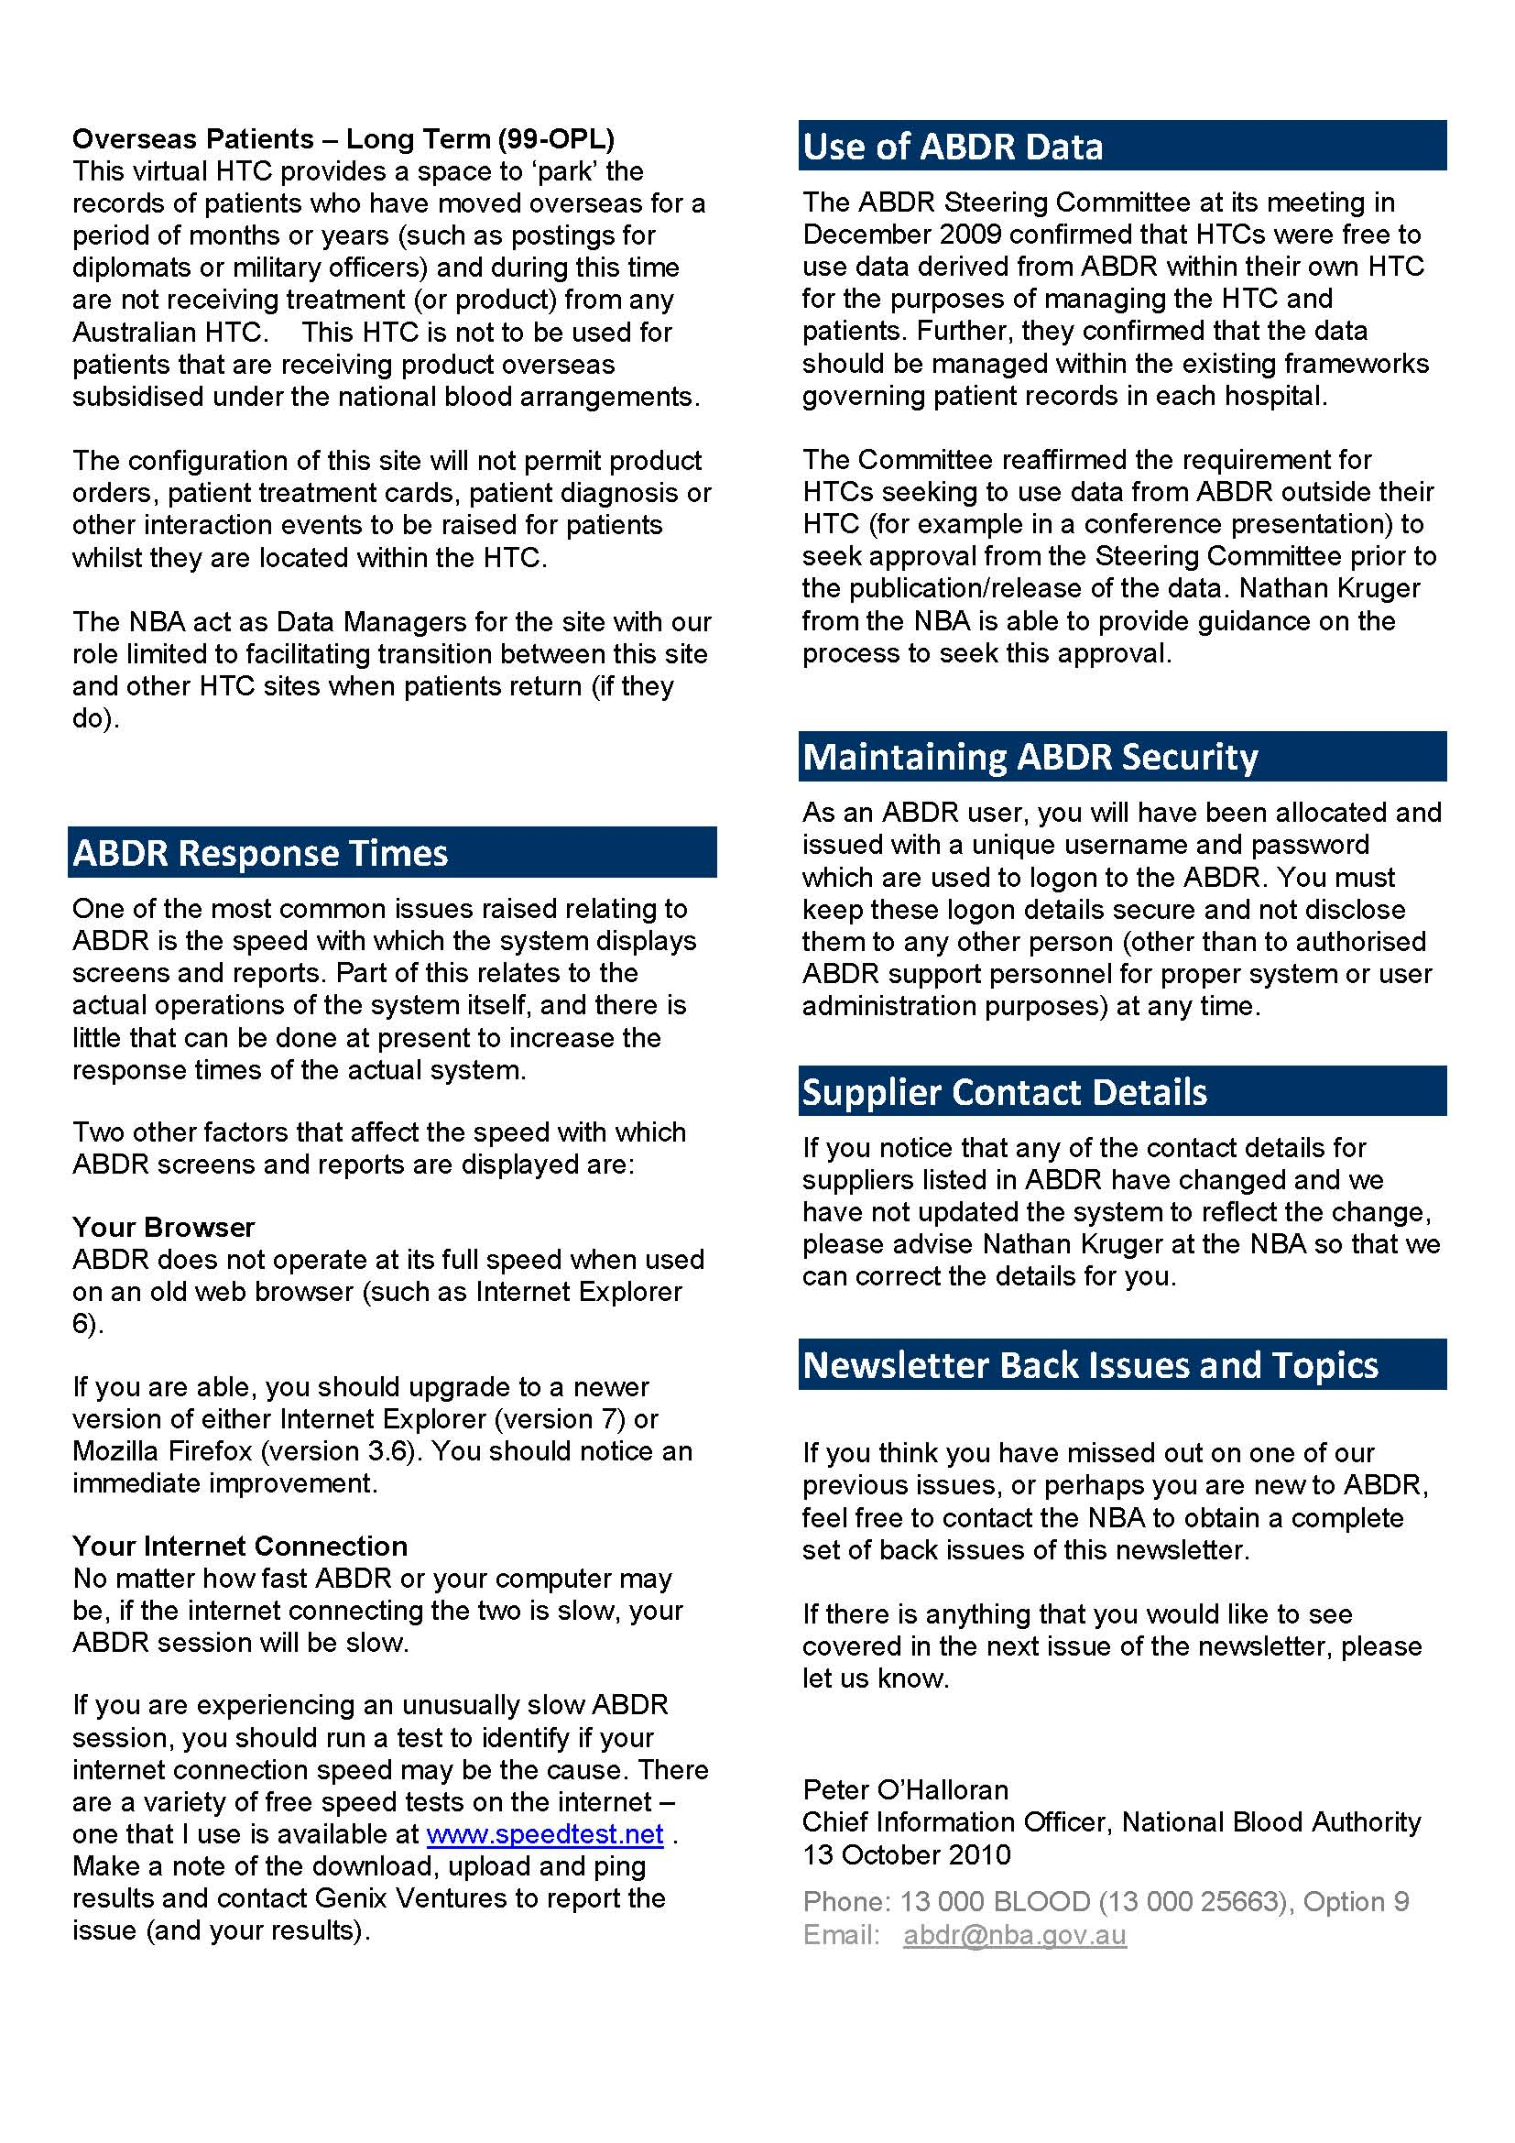
Appendix E

List of Figures
Figure 1 Location of HTCs 6
Figure 2 Age distribution of people in the ABDR by diagnosis at 30 June 2010 14
Figure 3 Distribution of severe Haemophilia A patients by HTC by year 16
Figure 4 Distribution of severe Haemophilia B patients by HTC by year 17
Figure 5 People in the register at 30 June 2010 with Haemophilia A or Haemophilia B by severity and home state (grouping small states) 17
Figure 6 Age distribution of people in the register at 30 June 2010 by severity 20
Figure 7 Age distribution of people in the register at 30 June 2010 with Haemophilia A and Haemophilia B by severity 21
Figure 8 HmA (Symp + Asymp) – Number of patients receiving treatment by severity 24
Figure 9 HmB (Symp + Asymp) – Number of patients receiving treatment by severity 25
Figure 10 vWD – Number of patients receiving treatment by type of vWD 25
Figure 11 International Units of product received by patients treated by purpose 26
Figure 12 Total issues of Factor VIII recorded in the ABDR issued to Haemophilia A patients divided by the number in the register who were treated, by home state of patient and severity in 2009-10 27
Figure 13 Median Factor VIII per Haemophilia A patients by state and severity in 2009-10 28
Figure 14 Weight and height data for ABDR patients receiving treatment 29
Figure 15 Age distribution of patients who received treatment in 2008-09 or 2009-10 compared with the Australian population 30
Figure 16 Age distribution at 30 June 2010 of Haemophilia A and Haemophilia B patients who received product in 2009-10 31
Figure 17 Annual international units of Factor VIII issued nationally 2003-04 to 2009-10 34
Figure 18 Annual international units of Factor VIII issued nationally per 1000 population 2003-04 to 2009-10 35
Figure 19 Annual international units of Factor IX issued nationally 2003-04 to 2009-10 35
Figure 20 Annual international units of Factor IX issued nationally per 1000 population 2003-04 to 2009-10 36
Figure 21 Annual international units of Factor VIII inhibitor Bypassing Activity (FEIBA) issued nationally 2003-04 to 2009-10 37
Figure 22 Annual international units of Factor VIII inhibitor Bypassing Activity (FEIBA) issued nationally per 1000 population 2003-04 to 2009-10 37
Figure 23 Annual international units of Recombinant Factor VIIa (NovoSeven) 2003-04 to 2009-10 38
Figure 24 Annual international units of Recombinant Factor VIIa (NovoSeven) per 1000 population 2003-04 to 2009-10 39

List of tables
Table 1 Major bleeding disorders and their cause 4
Table 2 Severity and the concentration of clotting factors 5
Table 3 Number of people in the register and treated by latest broad diagnosis 10
Table 4 Number of people in the register and treated by detailed diagnosis HmA, HmB and vWD 11
Table 5 Number of people in the register and treated by diagnosis of “other disorders” 12
Table 6 Number in register and receiving product by diagnosis of “Platelet disorders” 12
Table 7 People in the register at 30 Jun 2010 by broad age group, diagnosis and severity 13
Table 8 von Willebrand Disease in the register at 30 Jun 2010 by broad age group and vWD classification 15
Table 9 Comparison of the proportion of patients in the register and treated, UK and Australia, major diagnoses 2010 16
Table 10 Incidence of major disorders in Australia people with haemophilia per 100,000 of relevant population 18
Table 11 Incidence of bleeding disorders selected countries 2008 (per 100,000) 18
Table 12 Incidence of Haemophilia A in males in OECD countries (per 100,000) 19
Table 13 Incidence of Haemophilia A in males in selected countries by severity (per 100,000) 20
Table 14 Number of patients with inhibitors and comparison with UK 22
Table 15 Issues of Factor VIII to Haemophilia A patients UK and Australia 28
Table 16 National clotting factor costs 2008-09 and 2009-10 in $ million 39
Table 17 List of operational HTCs and their ID codes 44

Modified from Bolton-Maggs, PH & Pasi, KJ 2003, 'Haemophilias A and B', Lancet, 361 (9371), pp. 1801–1809. See also: White GC et al. Definitions in Hemophilia: Recommendation of the Scientific Subcommittee on Factor VIII and Factor IX of the Scientific and Standardization Committee of the International Society on Thrombosis and Haemostasis. Thromb Haemost 2001;85:560.
http://www.ukhcdo.org/
The UK publication did not have a split of treated by gender so we have split the treated in proportion to number in register.
PWH means people with haemophilia.
OBD means other bleeding disorders.

