# BloodNet goes west

BloodNet is now in Western Australia for the first time. Implementation began in Perth last week, with 10 sites “going live” during the week.

The initial sites were the Perth-based private laboratories, including CliniPath, Western Diagnostics, Healthscope, Mercy Hospital and the St John of God Hospitals in Subiaco and Murdoch. The WA roll-out was seamless, with staff at all sites rating the system as easy to learn.

Detailed planning and discussions are now underway with PathWest to schedule BloodNet implementations in the WA public sector. These implementations will cover all PathWest laboratories in metropolitan and regional WA.

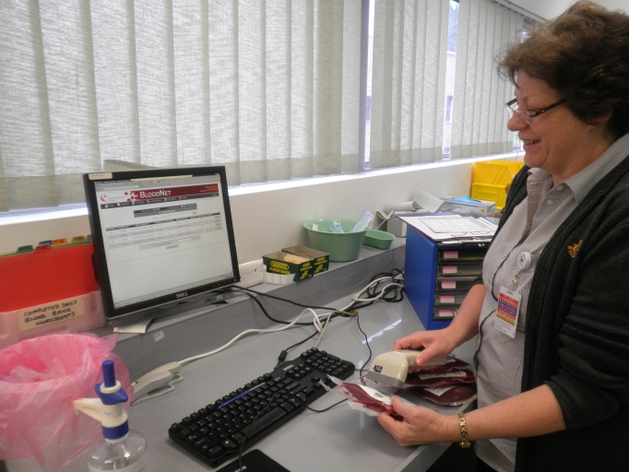

*Above: Peta Karvinen receipts her first order into BloodNet, immediately after completing her BloodNet training at Mercy Hospital in Perth.*

# NSW and ACT are next

In late August, BloodNet will be rolled out to all public and private pathology laboratories in the Australian Capital Territory and – for the first time – to six sites in New South Wales.

In the Australian Capital Territory, BloodNet will be implemented at The Canberra Hospital, Calvary Hospital, Capital Pathology and Healthscope Pathology.

The South Eastern Area Laboratory Services group (SEALS) will become the first laboratories in NSW to implement BloodNet in late August. Between them, these laboratories account for over 10% of the total volume of blood components and IVIg issued in New South Wales.

All these new additions mean that by the end of October, BloodNet is expected to be tracing more than half of the blood orders shipped by the Australian Red Cross Blood Service to laboratories across Australia.

By the end of August, BloodNet will be operating in all states and territories – albeit not at every site in each state and territory.

# BloodNet live in Darwin

The Commonwealth Parliamentary Secretary for Health and Ageing, the Hon Catherine King MP, saw BloodNet in action while on a recent visit to the Northern Territory. Staff at the Royal Darwin Hospital, including Senior Scientist Kelly Burns, gave a live demonstration of BloodNet, which was successfully implemented across the Northern Territory in April.

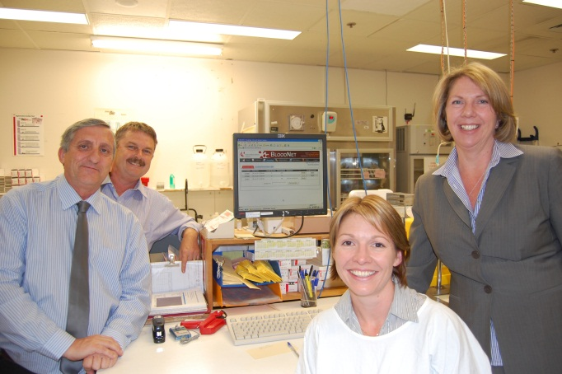

*Above: Parliamentary Secretary for Health and Ageing, the Hon Catherine King MP (right), was given a live demonstration of BloodNet by (from left to right) the Royal Darwin Hospital’s Laboratory Manager Michael Lynch, Microbiologist and Acting Director of Pathology Rob Baird and Senior Scientist Kelly Burns.*

# Receipting units with the same Donation/Lot Number

Your laboratory may receive blood components with the same donation number listed on one issue note – for example, Paediatric Red Cells “1 of 4” and “2 of 4”.

BloodNet will not know which component you are receipting simply by scanning the donor number. When BloodNet detects the same donation number multiple times, it will display a prompt box requesting more information. The box requests you to scan/type the “Component Code” of the item to receipt:

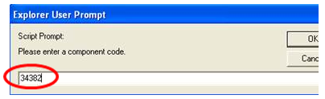

When the component code is entered, BloodNet will determine which line item you want to receipt and will receipt the correct line of the issue note, allowing you to receipt further items.

Alternatively, you may receive blood products with the same lot number listed on one issue note, for example, Thrombotrol-VF (see below).

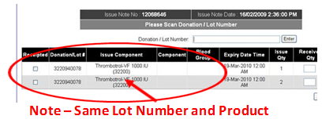

In this case, three identical products of the same lot number have been received but on two separate lines on the issue note. Scan the barcode for the product, and the first line will be ticked as being receipted. Continue to scan the next item, and BloodNet will automatically tick the next line it finds for that lot number and place a “1” in the ‘Received Qty’ box. You can then complete the second line by continuing the scanning process, or by manually changing the ‘Received Qty’ as required.

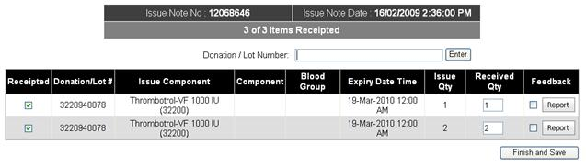

# BloodNet Training Site

Don’t forget when you are undertaking training or testing in BloodNet, there is a BloodNet training site that is accessible to all BloodNet users. The training site is always running the same version of BloodNet as the actual BloodNet site so you can rest assured that the two environments are exactly the same.

The website address for the training site is <https://www.blood.gov.au/training>. Your username and password for the training site are the same ones that you use to log into the main, production version of BloodNet.

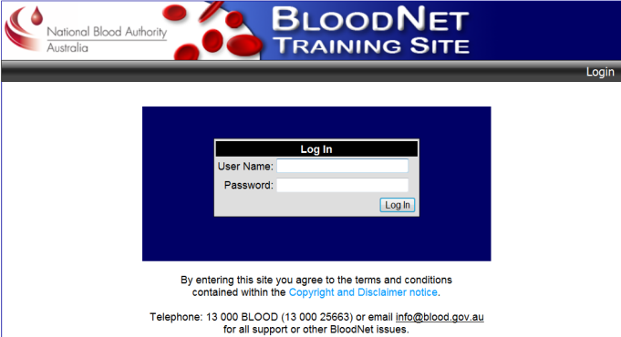

If you still need additional assistance, or perhaps a one-on-one remote training session on BloodNet, don’t hesitate to contact BloodNet Support (contact details below).

# BloodNet User Reference Group (BURG)

Thank you to the members of the BloodNet User Reference Group (BURG) for their recent input into the configuration of key fields such as *Reason for Discard* and *Location responsible for or causing to be discarded* in the ongoing development of the BloodNet fate module.

The time that we ask of members of BURG is small, but the benefit to the NBA and end users is great.

We are always keen to have additional members join the group – particularly those from the private sector laboratories who are not yet represented on BURG.

To join, email BloodNet Support [info@blood.gov.au](mailto:info@blood.gov.au) with your contact details and we will be pleased to add you to the group.

# BloodNet Enhancements

Our developers, Paul Pratt and David Sneddon, have been busy over the last few months perfecting the next major version of BloodNet (v2.5) which is currently undergoing the final stages of internal testing within the NBA before being released for external User Acceptance Testing in the coming fortnight.

In addition to the usual minor system enhancements and modifications, there are a wide variety of enhancements in this new build, with the key ones including:

**1. Issue Note format changes**  
The format of the Issue Note provided by the Blood Service to BloodNet will be changing in the coming months, which has necessitated a significant overhaul of the application code base to enable us to successfully interpret the new format Issue Notes.

As the Issue Notes are the source for data on units issued by the Blood Service in BloodNet, this was a crucial enhancement that we are pleased to advise is now completed.

**2. Server upgrades**  
The BloodNet servers will be upgraded to ensure that performance remains at an acceptable level with the introduction of additional laboratories as part of the ongoing implementation of BloodNet across Australia.

**3. Component and Product Changes**

Components and products that have been phased out (such as Refacto and Sandoglobulin) will no longer be able to be ordered in BloodNet.

Conversely, new components and products that have been introduced (such as Kogenate and Rhophylac) will be available to order in those jurisdictions where these items are distributed through the Blood Service.

**4. Contact details for BloodNet Support**  
The contact details for BloodNet Support will be under the *Help* menu to make them easier to locate when you are logged into BloodNet.

**5. Feedback**

The feedback pop-up on the receipting screen will be modified to provide a more intuitive and easier way to place or remove feedback items. The most visible of these changes will be the introduction of a new button – *Clear Feedback* – that can be used to remove all trace of a feedback item that was created in error (see below).

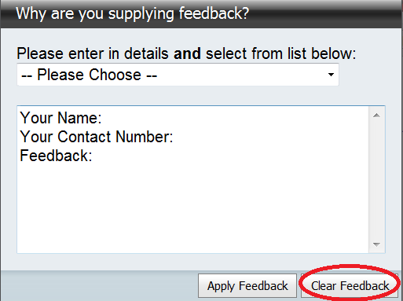

**6. Component and Manufactured Product Prices**  
The price lists for both components and manufactured products in BloodNet will be updated and include historical pricing back to the 2008-09 Financial Year.

Following requests from a range of users (particularly from those in jurisdictions with devolved blood budgets), the system will have the price of components and manufactured products in both the ordering and receipting screens. This provides staff members placing orders with a clear indication of the estimated cost of these items to Australian Governments. It should be noted that the prices may differ from those prices that may be applied by individual jurisdictions to those facilities with devolved blood budgets.

Prices will appear on the routine order templates and also on the subsequent screen when you confirm the location to which your order should be sent.

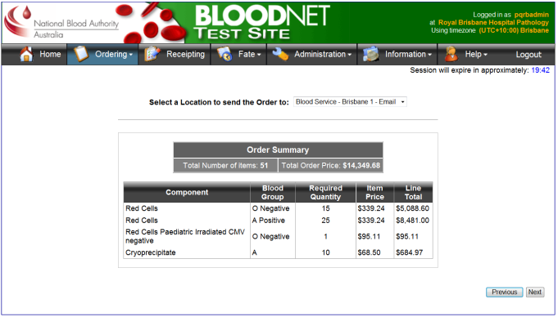

Prices appear on the receipting module of BloodNet and are visible in both the actual receipting screen and on the screen where you select the Issue Note(s) to receipt.

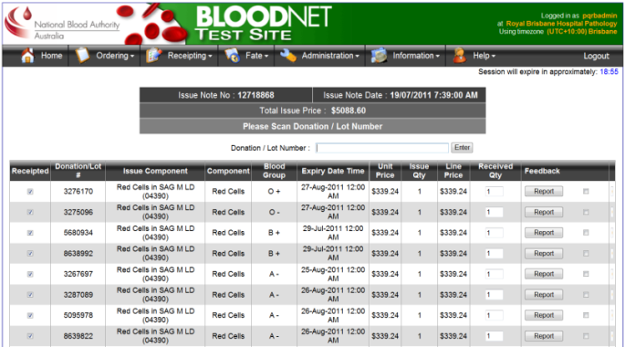

**7. Fate**

The Fate module will quickly become an integral part of BloodNet and will provide data to inform laboratories, hospitals, suppliers and governments on supply chain trends.

Initially, the Fate module will be populated by end users in laboratories keying/barcoding in data as currently occurs with ERIC. However, as the work on BloodNet-Laboratory Information System interfaces progresses, the Fate module screens will provide a way for users to view the data that has been transferred through an interface. In this manner, we expect over time that there will be no need for those with an interface implemented to enter in any discard data manually.

The Fate module will be comprised of four primary components:

* **Discard**, which enables users to record the discard of components and products. This replaces the current functionality in ERIC, along with a number of additional enhancements.
* **Transfer**, which enables users to record the transfer of components and products between laboratories. This will enable the capture of data on stock transfers to minimise wastage and enable the sector to better measure the scale of hub and spoke type distribution arrangements in some laboratories.
* **Transfuse*,*** which will enable users to record that a unit was transfused to a patient and the purpose of that transfusion at the DRG level.
* **Reporting**, which will enable users to generate their own reports on discards, transfers and transfuse records on demand.

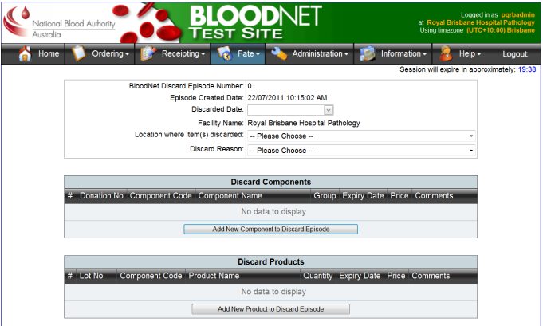

The Fate module has been split into three phases:

* **Phase 1** – comprising Discard functionality
* **Phase 2** – comprising Transfer and Reporting functionality
* **Phase 3** – comprising Transfuse functionality.

Phase 1 (Discard) will be released as part of the next release of BloodNet, with Phases 2 and 3 scheduled before the end of the year.

**Further Information**

A detailed set of explanatory materials relating to all of these changes is being developed in parallel with the final testing of the enhancements. They will be released in the coming weeks prior to the system changes moving into production.

These materials will outline the rationale for the changes, differences that users can expect and will also be accompanied in the coming months by a national roadshow to demonstrate the new Fate module.

# BloodNet Upgrade Date

The upgrade to the next version of BloodNet will occur during August, with the exact date to be set in the coming week. We will notify all users of the date as soon as it is confirmed.

Authorised by Peter O’Halloran,   
Chief Information Officer, National Blood Authority

26 July 2011