Celebrating 100,000 BloodNet orders
A major milestone in the life of BloodNet was reached when the 100,000th order was placed in May.

The Transfusion Medicine team at the Royal Hobart Hospital was the lab to hit the “Send” button that lodged the 100,000th order on 19 May.

To mark the occasion, a morning tea with the Hobart team and Hobart based staff from the Blood Service was held at the hospital on 2 June,

The NBA’s Chief Information Officer Peter O’Halloran presented a plaque to the Royal Hobart Hospital’s Senior Scientist Gina Aitken. He was joined by the then Jurisdictional Blood Committee representative for Tasmania, Tony Sansom.

“This is a major milestone in the life of BloodNet because 100,000 is more than just a big number in itself,” Peter said.

“It equates to 1.3 million individual components and products that have been tracked through BloodNet since its inception in Queensland.

He said the figures show the rapid expansion in the use of BloodNet across the country.

“Any lab from the Northern Territory to South Australia and across to Queensland could have been the one to hit the magic 100,000 order,” he said.

“In this case, it was Tasmania and I was delighted to share this celebration with them.”

Marking the 100,000th BloodNet order are Leigh Hill (Australian Red Cross Blood Service), Peter O’Halloran (National Blood Authority), Gina Aitken (Royal Hobart Hospital) and Tony Sansom (Tasmanian Dept of Health & Human Services).

Issue Note format change
Issue Notes for items that are despatched to your facility can be viewed in BloodNet (either through the ‘Receipting’ tab or through a search under the ‘Information’ tab).

Currently, these Issue Notes are provided in a text-based format and displayed within the body of the BloodNet screen. In late July, the format of these Issue Notes will change to PDF.

To ensure that you can continue to access Issue Notes in BloodNet following this change, you should check that you have a PDF reader (such as Adobe Acrobat, Foxit Reader, Okular or Evince) installed on computers that are used to access BloodNet.

If you do not have them installed, you should discuss the matter now with your local ICT support area to ensure that the matter is resolved before the Issue Note format change.

The case of the disappearing faxes
The cut-over of BloodNet orders from fax to encrypted email for the Blood Service Distribution Centres in Adelaide and Hobart on 16 May went smoothly.

From 9am on Monday 20 June 2011, all orders for the Blood Service’s Darwin Distribution Centre will transition from faxed orders to encrypted email orders. Users in the affected facilities in the Northern Territory do not need to do anything differently with the cut-over. The only noticeable difference is that the fax icons will be replaced by email icons:

The order has been sent to the Blood Service, but they have not yet confirmed receipt of the order

The order has been sent to the Blood Service and they have confirmed receipt of the order
BloodNet retains the capability to fall back to faxed orders to all Blood Service Distribution Centres as part of our contingency arrangements should the encrypted email link ever fail.

Recording feedback
There will be occasions when your order cannot be 100% receipted by scanning such as when a product listed on the Issue Note was not received or was damaged.

In such cases, it is important to ensure that feedback is recorded accurately for automated reporting to the Blood Service by following these steps:

- Click the report button in the feedback column.
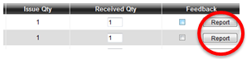
The ‘Why are you supplying feedback’ window will come up and you should then select the appropriate reason for the feedback.
- Enter you details in the final text box – your name, your contact number and feedback. Please ensure that you provide sufficient information to enable the Blood Service to act on your feedback.
- Click the ‘x’ button to close the pop up window. Note that the ‘Feedback’ check box is now ticked, the Report button is now displayed as a red box and the wording has changed from ‘Report’ to ‘Edit’.
If you are supplying feedback for a number of items from the same Issue Note you must repeat the above for each item. If you have entered feedback in error and need to remove it, you can do so by simply clicking the ‘Remove’ checkbox. If there is an urgent problem with a delivery, the Blood Service should also be notified by phone.

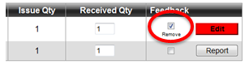

Searching for Donation or Lot Numbers
If you need to search for a specific Donation or Lot Number in BloodNet, you can do so by using the ‘Search Donation Lot Number’ report which is accessible in BloodNet. (Select the ‘Information’ menu item and then the ‘Report’ sub-menu item).

Saving Draft Orders
If you are halfway through creating an order and get called away to something more urgent, don’t forget that you can save the order and come back to it later.

When you are creating an order, simply select the ‘Save Order and Complete Later’ button at the bottom of the order entry screen. The order is then saved as a draft by the system and is accessible from the ‘Unsent Orders’ tab.

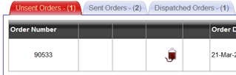

Unsent orders can then be selected, completed and transmitted to the Blood Service or alternately can be selected and cancelled.

Orders on the ‘Unsent Orders’ tab will automatically be moved to the ‘Cancelled Orders’ tab after five days.

First meeting of the BloodNet User Reference Group
The BloodNet User Reference Group (BURG) met for the first time on 31 May 2011 by teleconference. After dealing with the formalities of a newly established group, a range of issues were discussed including further updates on system developments, LIS interfaces and enhancements.

The Group also discussed the modifiers ‘As Fresh As Possible’ and ‘<5 days’ and this issue will be explored further with all users in the upcoming user survey.
BURG is chaired by Peter O’Halloran from the NBA and current members are:
- Gina Aitken – Royal Hobart Hospital
- Gerald Bates – Launceston General Hospital
- Kelly Burns – Royal Darwin Hospital
- Ken Davis – Royal Adelaide Hospital
- Geoff Magrin – Alfred Hospital
- Sandy Russell – Cairns Base Hospital
- Sue Williams – Royal Brisbane Hospital
The notes from the meeting will be made available online shortly.

New members are always welcome and you can nominate yourself for membership at any time by emailing BloodNet Support.

ABDR and IVIg Reports Published
The NBA has recently published the ABDR Annual Report and a report on the use of intravenous immunoglobulin (IVIg).

The reports are available from the NBA website (www.nba.gov.au) and hard copies can be obtained by emailing your details and the quantities of each report that you desire to BloodNet Support.
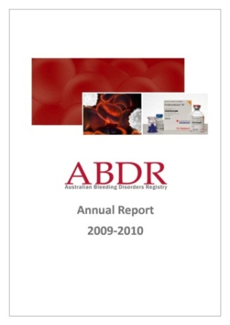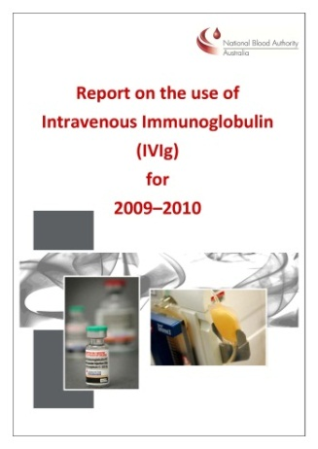

The NBA intends to publish each report on an annual basis and they form a key part of our increased focus on the analysis and dissemination of key data in the blood sector. Further information and data relating to the Blood Sector is available in the NBA’s Annual Report (also on our website).

On a mission to interface with LIS
Feedback has indicated that one of the most important priorities for users is to build an interface between BloodNet and the Laboratory Information Systems (LISs) used in Australian hospitals.

The Proof of Concept trial to interface BloodNet into three LISs is currently underway and we hope to commission the first interface (into PathWest’s ULTRA) in the coming weeks. Work to interface into two other LISs (Auslab through Queensland Health and eBlood through NSW Health) is progressing well and we are hopeful that we will have another interface fully operational by the end of 2011.

We will be reporting on further developments in coming issues of this Newsletter.

In the meantime, we thought it could be useful to explain what an interface between BloodNet and your LIS could deliver.

The interface provides a seamless, automated and almost real-time (once every 1-2 minutes) data exchange between BloodNet and your LIS.

Three separate data streams are provisioned through the interface:

- Hospital inventory levels which populate the ‘On Hand’ values in Routine Order Templates and are also passed to the Blood Service (to populate the National Inventory Template), your State or Territory JBC member and the NBA.
- The fate (ie transferred to another hospital, discarded or transfused) of each unit (which will automate the majority of the current discard reporting through ERIC).
- Component details (such as component type, blood group, collection and expiry dates, modifiers and phenotypes) upon being receipted into BloodNet will be passed to your LIS. This will enable an automated upload of the data into your LIS to remove the requirement to double-receipt that exists at present.

These data streams are depicted graphically below.

Not only should such interfaces dramatically reduce the data entry time required (for tasks such as receipting and recording fate), they will also provide a real-time view of blood inventory levels across the country at the AHP level for the first time

Authorised by Peter O’Halloran, Chief Information Officer, National Blood Authority, 17 June 2011.

