BloodNet on a roll
The national roll-out of BloodNet is gathering speed, with all Northern Territory hospital laboratories now on board and the last four South Australian sites to “go live” next week.

Trainers from the National Blood Authority were in the Northern Territory from 26 to 30 April to implement BloodNet at all public and private hospitals. The implementation went without a hitch.

Meanwhile, in South Australia, BloodNet has been implemented in all but four hospitals across the State and those four sites are about to switch over to BloodNet in the coming week.

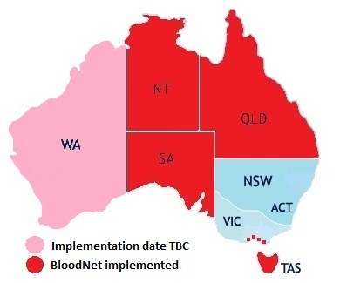

After that, BloodNet will most likely make its way across the Nullarbor to Western Australian before returning to the Australian Capital Territory.
Discussions are underway with the Departments of Health in New South Wales and Victoria and good progress is being made.

The National Blood Authority’s Chief Information Officer Peter O’Halloran said the system had been embraced Australia-wide.
“There has been much interest in BloodNet from staff working at both the Blood Service and in hospital-based blood banks in all the states and territories,” he said.

“It is clear that staff responsible for ordering blood can see the benefits of BloodNet to making their jobs easier – especially in reducing their time spent on blood orders – as well as improving inventory management and financial accountability.

“The support from Blood Service staff has been terrific and has been integral in the success of the implementations.”

BloodNet impresses new users in the Territory
The roll-out of BloodNet across the Northern Territory was a resounding success.

Six hospital laboratories from Darwin to Alice Springs were inducted into the BloodNet family in late April. Face-to-face training sessions were held at:
- Royal Darwin Hospital
- Darwin Private Hospital
- Alice Springs Hospital
- Katherine Hospital
- Gove District Hospital
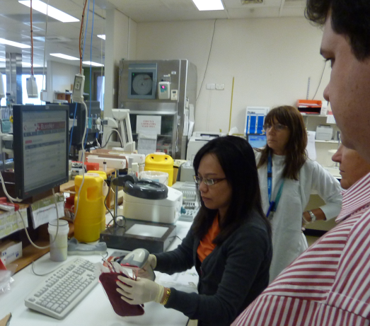
BloodNet training at the Royal Darwin Hospital
Staff at Tennant Creek were given remote training via web-conferencing and teleconferencing after they were unexpectedly unavailable while the BloodNet trainers were in town.

All laboratory staff who took part in the training were impressed with the new system and its ease of use.

Jane Darvall, Supervising Scientist Blood Transfusion at Royal Darwin Hospital Pathology, said that after only one week of use, BloodNet had already been able to identify that an order had not been dispatched by the Blood Service in Perth. She said staff were getting used to using the new system and she looked forward to it being rolled out to the rest of Australia.
“It will be good when it is used Australia-wide as we receive product from around the country – most recently an order to WA was filled by NSW who are not on the system.”

The case of the invisible Issue Notes
If you attempt to receipt items in BloodNet and the Issue Note does not appear, you should call the Blood Service and ask them to reprint it using the PDH printer. An Issue Note should then appear in BloodNet within 10 minutes.

Say goodbye to faxed orders
At present, most orders in BloodNet are converted by BloodNet into a fax that is then transmitted through to the Blood Service.

From 9am on Monday, 16 May, all orders that are sent to the Adelaide and Hobart distribution sites of the Blood Service will be sent by encrypted email rather than by fax.
They will be falling in line with all Queensland and Perth distribution sites, who already receive orders by encrypted email.
The change is necessary because emailed orders are faster and more reliable than faxed orders. They are also more secure because all details on emailed orders are encrypted so that third parties cannot view what is in the data stream.
Users in affected laboratories do not need to do anything differently with the cut-over from faxed orders to encrypted emails, the only difference that will be noticed is that the fax icons will be replaced by email icons:

The order has been sent to the Blood Service, but they have not yet confirmed receipt of the order

The order has been sent to the Blood Service and they have confirmed receipt of the order

The NBA is working closely with the Blood Service to change over from faxed to encrypted email for orders that go to the Darwin and Melbourne distribution sites.
BloodNet is now providing the order data to the Blood Service in a machine readable format which will enable them in the future to examine the feasibility of integrating this feed electronically into their systems, further reducing the potential for keying errors.

Apheresis Platelets now available in routine orders
Apheresis Platelets can now be ordered from the Blood Service through routine orders.
Laboratory users with Administration rights in BloodNet will need to add these into their laboratory routine order templates by going into the Administration menu in BloodNet, selecting ‘Edit Facility Details’ and then ‘Add Component’ and selecting the appropriate components to add. Don’t forget to update the ‘Max Stock’ levels.

If you get stuck, the process is outlined in section 10.1.4 of the BloodNet Manual (on page 44) or you can contact BloodNet support (details at the bottom of this page).

Last call for standing orders
The Blood Service is phasing out Standing Orders nationally by 30 June and facilities that still have standing orders in place should discuss it with their local Blood Service team.

Introducing the BloodNet User Reference Group
Five brave souls have already nominated for the BloodNet User Reference Group – should you join them?

The BloodNet User Reference Group (BURG) is a new group being set up to give users a direct say in the way BloodNet operates including input into system developments and enhancements.

The group will meet informally, mostly via teleconference, and will include users from around Australia.

The inaugural meeting of BURG will be conducted by teleconference on Tuesday, 31 May commencing at 3pm (Eastern Standard Time).

There is still time to nominate if you or someone in your work team would like to participate. To nominate, please contact BloodNet support (details at the bottom of the page).

Tell us what you think
A BloodNet User Survey will be circulated in June, to give all users a chance to voice their opinions and to seek ideas on what can be done to improve or change BloodNet to make it more user-friendly.

Look out for the survey in your email inbox over the coming weeks.

New training option now available
Remote training is now available to new senior laboratory staff needing an introduction to BloodNet.

Training is done via computer and telephone, using a live trainer to run through the system and answer any questions along the way.

Both trainer and trainee are viewing the same computer screen during the demonstration (This is despite them not being in the same room together – or even in the same part of Australia!).

Ideally, this training option would suit laboratories where a new senior staff member has joined the team and is unfamiliar with using BloodNet.

You need only a computer with internet access and a telephone to take part – all the technical details are handled by the trainer.

The National Blood Authority is also developing a series of training videos for laboratory users to brush up on the finer points of BloodNet.
These training videos are expected to be available over the next few months.

Nathan Kruger (NBA ICT Operations Manager) remotely training laboratory staff at the
Tennant Creek Hospital in BloodNet

BloodNet enhancements
The Applications Development team are furiously working through on BloodNet enhancements with work on the Fate module powering ahead. The team are looking forward to the module entering the user acceptance testing period in the coming weeks and we will be seeking nominations from interested BURG members to assist in this process.

Work on the new security model (which will give each user their own unique logon for BloodNet amongst other things) has continued to be placed on hold whilst development work is focused on adjusting BloodNet to cope with the new format of Issue Notes that will be received from the Blood Service when their upgrade of their National Blood Management System (NBMS) from Progesa to eProgesa occurs in the coming months.

Don’t get stuck – check the new User Manual
If you have a query about BloodNet, the User Manual is a comprehensive source of help.
The User Manual was updated on 21 March, so if you haven’t already accessed the new version, please log onto BloodNet and download the latest version (select the ‘Help’ menu and then ‘BloodNet Documentation’).

…..or the Business Rules
The Business Rules should be your first port of call if you encounter something unusual when using BloodNet. They contain the top ten issues users report – and what to do.

Examples cover common problems from “You received more/fewer units than shown on the Issue Note” to “Product is damaged in transit”.
The Business Rules contain the process for dealing with these issues, as agreed by the Blood Service and the National Blood Authority.

You can download the Business Rules from the ‘BloodNet Documentation’ section in BloodNet (see above)

But if in doubt…
Don’t forget to call BloodNet Support for assistance at any time. You can reach us by email (BloodNet@nba.gov.au) or by telephone (13 000 BLOOD / 13 000 25663). Our telephone support line is staffed 24 hours a day, 7 days a week.

Blood Service Project Leader
The Blood Service has recently seconded Natalie Saint (their WA Inventory & Distribution Manager) to a new position for three months as their BloodNet Project Leader to coordinate all matters BloodNet within the Blood Service.

Natalie was recently involved in the implementation of BloodNet in the Northern Territory and has first-hand experience of the impacts of BloodNet on Blood Service operations.

Natalie, welcome to the BloodNet family!

BloodNet User Manual

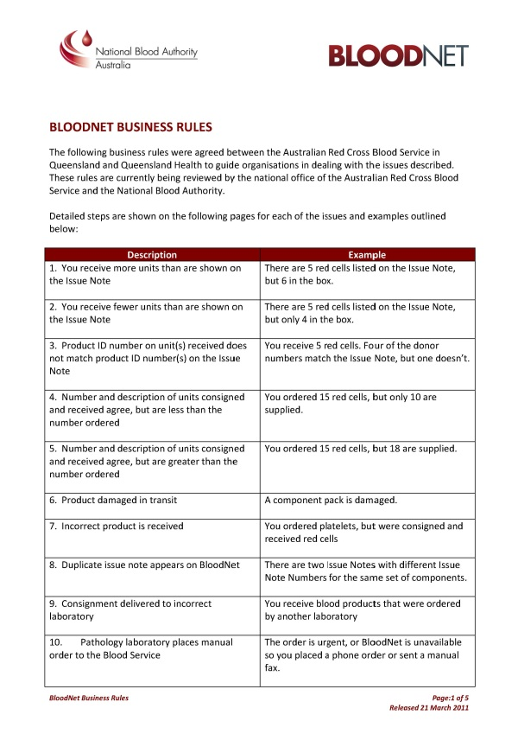
BloodNet Business Rules

Authorised by Peter O’Halloran,
Chief Information Officer,
National Blood Authority

12 May 2011

