Merry Christmas from the BloodNet team!

On behalf of the BloodNet Support team and all staff at the National Blood Authority we would like to wish you a Merry Christmas and a Happy New Year!

BloodNet Support will continue on as normal with our 24hr, 7 day a week phone and email support, please contact 13 000 BLOOD (13 000 25663) and for any non-urgent enquiries please email bloodnet@nba.gov.au.

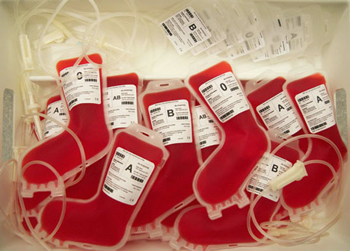

BloodNet Moves to Individual Logins with the BloodPortal

The BloodPortal is the National Blood Authority’s central user management and authentication system that controls access to multiple systems, this will now include BloodNet. Not only will this save you from remembering a lot of passwords, you can update your contact details for the NBA in one place, subscribe to a range of mailing lists on specific topics and readily access other systems such as BloodChat and the Australian Bleeding Disorders Registry (if you are an approved user of ABDR).

Only 24 Days Left to Create your Individual Logins for BloodNet

- Development of the BloodNet Access Pages in the BloodPortal
The BloodNet access pages are now available by logging into the BloodPortal at portal.blood.gov.au and creating your own username and password.
Please note it was previously advised that passwords will expire in 90 days, this will now be extended to 180 days.
Once you have access to the BloodPortal please then click on the BloodNet tile and request access to all sites you are currently access BloodNet at.

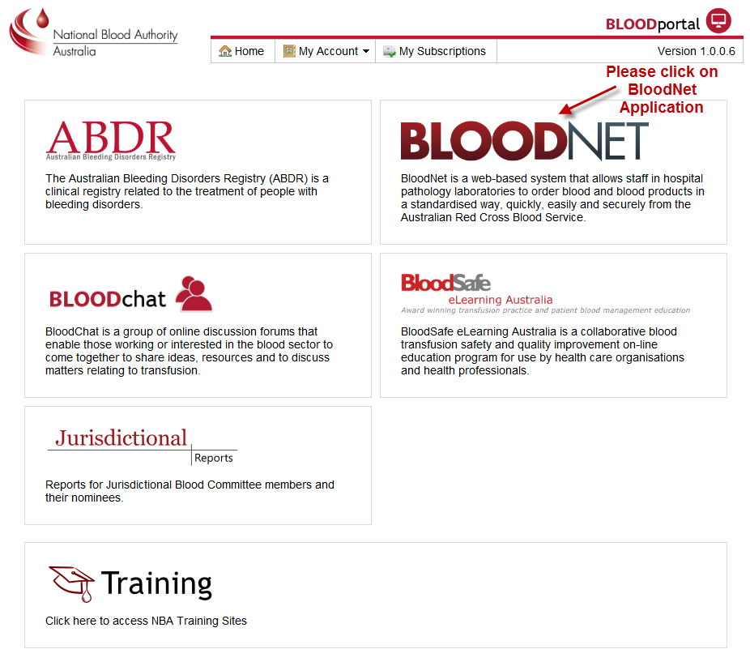

Important dates to remember:

As of 3 December 2012 all users nationally were asked to create their BloodPortal logins and request access to BloodNet.
On 11 January 2013 all users must have created their BloodPortal accounts and have requested access to their BloodNet sites.
From 19 January 2013 all generic usernames and passwords will be disabled and you will then only be able to access BloodNet through your individual login in the BloodPortal.

If you are still to complete the BloodNet survey sent on 7 November 2012 please contact BloodNet Support urgently on 13 000 BLOOD (13 000 25663).

- Reporting Page
The Reporting page has been revamped to accommodate easy access to all reports.
Reports are now grouped into three easy to access groups.

Fate Reports:
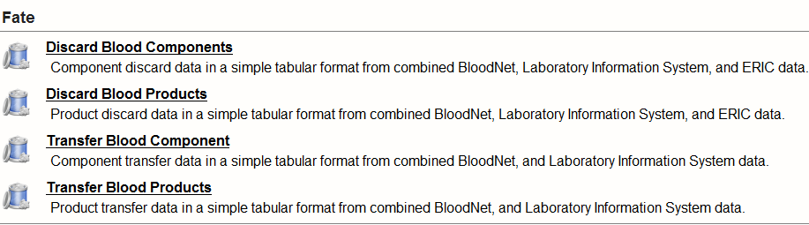

Feedback Reports:
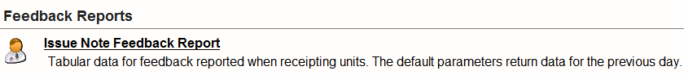

Inventory Reports:
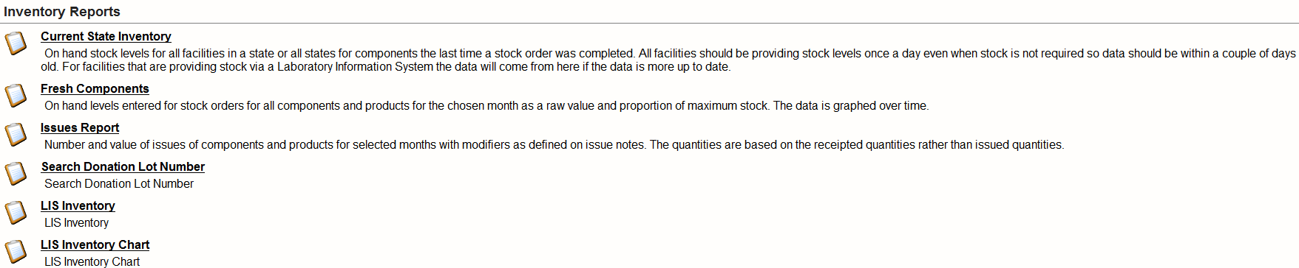

We have had some reported performance issues with generation of reports. Work has been taken to resolve this issue and will be integrated to reporting in the improvements BloodNet build release on 19 January 2013.

- Infusion Date
Since 26 October 2012 ‘Infusion Date’ has been a non-mandatory field when completing a patient specific new ‘Special Order’. A reported issue has been rectified in the build release on 1 December 2012 so that the infusion date correctly prints on the order template.

The use of the ‘Infusion Date’ is not mandatory but is highly useful for your pathology and the Blood Service for platelet and IVIg orders. The use of the infusion date will increase the information sent to the Blood Service, enabling them to provide product and components in the adequate amount of time with sufficient time to expiry.

Please see below the location of the ‘Infusion Date’ box, available if required for all special orders.

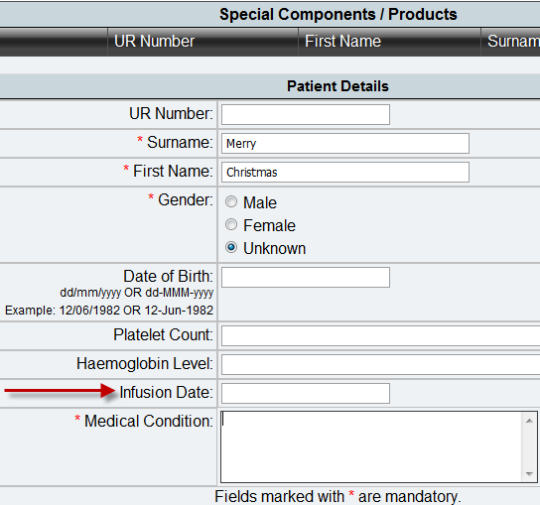

Fate Module Rollout

The rollout of the BloodNet Fate module continues with key sites around Sydney and regional NSW receiving training in the weeks leading up to Christmas.

The Fate module is for all Discards and Transfers of blood and blood products and will be replacing ERIC. If you are yet to receive training in the Fate module and are keen to go live with Fate at your laboratory then don’t hesitate to contact BloodNet Support to schedule training for you and your staff. Fate training takes a maximum of 30 minutes and can be conducted online or face to face if available.

Below are the statistics of the Fate module rollout as of 17 December 2012.

Jurisdiction | Fate Module
NSW | 64%
VIC | 77%
QLD | 91%
SA | 91%
WA | 89%
TAS | 95%
NT | 100%
ACT | 92%
National | 82%

Feedback on BloodNet training

Feedback from the BloodNet rollout at South West Pathology Service Wagga Wagga:

“SWPS-Wagga underwent BloodNet training in early October. The BloodNet trainer was gracious enough to visit our laboratory and take us through the BloodNet system. They were wonderful and our time spent training with them was invaluable. The flexibility of the training allowed us to get a maximum number of staff trained and exposed to the new system. With the training our staff quickly grasped the new system and were eager to start using it within the laboratory.

Once we went live with BloodNet all staff within the laboratory were amazed at how user friendly the system was and how easy it was to use on a daily basis. We have enjoyed moving onto the BloodNet system and have found many of the features extremely helpful, especially the ‘Dispatched’ screen that allows us to see what products we are being sent and the features of those products such as expiry, phenotype and so forth. “ (Shylee Rutland, Scientist in Charge of SWPS Wagga Wagge Laboratory).

Key Reports
One of the key reports commonly used by the BloodNet Support team and could be of valuable assistance to BloodNet users is the Search Donation Lot Number Report.
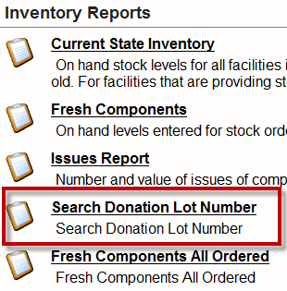

This report will allow you to search for specific donation lot numbers and drill down into detailed information about that donation lot number.

The report will outline the site that originally received the unit, if it has been transferred or discarded and which site that occurred.

If you are getting errors while trying to create a discard and transfer episode this report should be your first step of enquiry as it will tell you if the unit is located at your site or if it has not been transferred to you, if the unit has not been receipted or if it has already been discarded.

If you have any questions about the use of this report or any others please don’t hesitate to contact BloodNet Support.

BloodNet User Reference Group Meetings 2013

The BloodNet User Reference Group meets quarterly for feedback and discussion about the growth of BloodNet and any enhancement requests.
The group will be meeting via teleconference on 14 February 2013 and new users are always welcome. If you are interested in having input into BloodNet please contact BloodNet Support to put forward your name for the next meeting.

Pending Access Requests for Individual Logins to BloodNet

We currently have 55 access requests awaiting approval by Facility Administrators at multiple sites nationally.

To see if you have users to approve please login to the BloodPortal, click on the BloodNet link.

Then click on the Access Requests at the top rights hand side of the page. You will then be able to see who is requesting access to which site and approve or reject them.

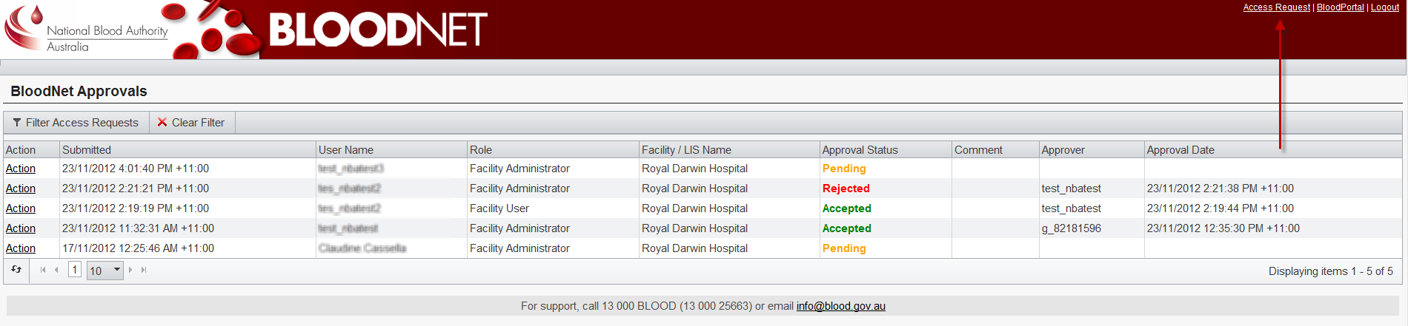
BloodNet Scheduled Outages for 2013

The next BloodNet schedule outage will be held on Saturday 19 January 2013. This build will focus on the migration of all individual logins and disabling of the generic logins currently used to access BloodNet. This build will also see the introduction of new reports and enhancements and improvements of the reporting section of BloodNet. Further information will follow early in the New Year on these reports.

The following builds in 2013 will be in early April, July and October. The April build will have a strong focus on user feedback enhancements. If you have any requests or suggestions please send them through to bloodnet@nba.gov.au.

