What are the side effects?

All medical treatment products, including blood products, have risks.

The most common reactions or side effects to immunoglobulin products are:

* tiredness
* headache
* nausea (feeling sick)
* stomach and back pain

Rarely, more serious allergic reactions occur. Symptoms include:

* shortness of breath
* wheezing
* tongue/throat swelling
* chest tightness
* skin rash
* dizziness
* low blood pressure

Very rarely there can be an increased risk of blood clotting which in some people may contribute to heart attack, stroke or other vascular problems or worsening renal failure. These almost only occur in people who already have risk factors.

**Any of these or any other symptoms should be reported to a doctor or nurse immediately, or before your next treatment.**

How is the dose determined?

The treatment dose varies with each diagnosis and is also based on body weight. The dose given, the timing between treatments and the number of treatments given depends on your response to treatment and test results. Your doctor will inform you of what is best for you and look at your progress at set times. It is important that your doctor sees you at regular intervals to make sure the treatment is working and to make changes if needed.

What is immunoglobulin treatment?

There are two types of treatment:

* Replacement – immunoglobulin infusions given to people whose body is unable to produce enough antibodies to maintain a healthy immune system. These conditions can be inherited (primary) or acquired (secondary) due to certain diseases or treatments.
* Immunomodulation – immunoglobulin treatment given to people when there is an autoimmune disorder diagnosed and the immune system attacks its own body tissues by mistake. Treatments vary with each diagnosis and may be for a single dose or short course of treatment, or for treatment over a longer period. Regular check-ups may be required to measure your response and ensure the best treatment options are used.

You will be asked to provide your verbal or written consent to the collection, retention and use of personal information and clinical data to assess authorisation for initial and continuing access to government funded product.

A summary of this information, which will be un-named to protect your privacy, may be used to assist in planning and managing the supply of SCIg products, and to improve treatment programs.

If you don’t qualify for government funded product, there are other options available. Please see the National Blood Authority website (www.blood.gov.au) for more information.

What are the risks of infection from a   
blood product?

All immunoglobulin products have been screened and tested to protect patients from diseases such as hepatitis (B and C) and human immunodeficiency virus (HIV/AIDS). These products have also gone through at least two processes that destroy viruses. There is a risk of infection but it is very low. In Australia, there has never been a reported case of an infection from this treatment.

Self-administered therapy with SCIg

Depending on your condition and circumstances, you may be offered SCIg therapy for self-administration outside hospital. You will be provided with a Patient Receipt and Use Diary to record your treatments. This information will need to be provided regularly to your doctor or supporting nurse.

You must tell hospital staff if you have not used any SCIg that has been provided to you and the reason. This could be because it was accidentally broken, expired, had visible particles or because of a reaction that you had and did not use the entire product.

 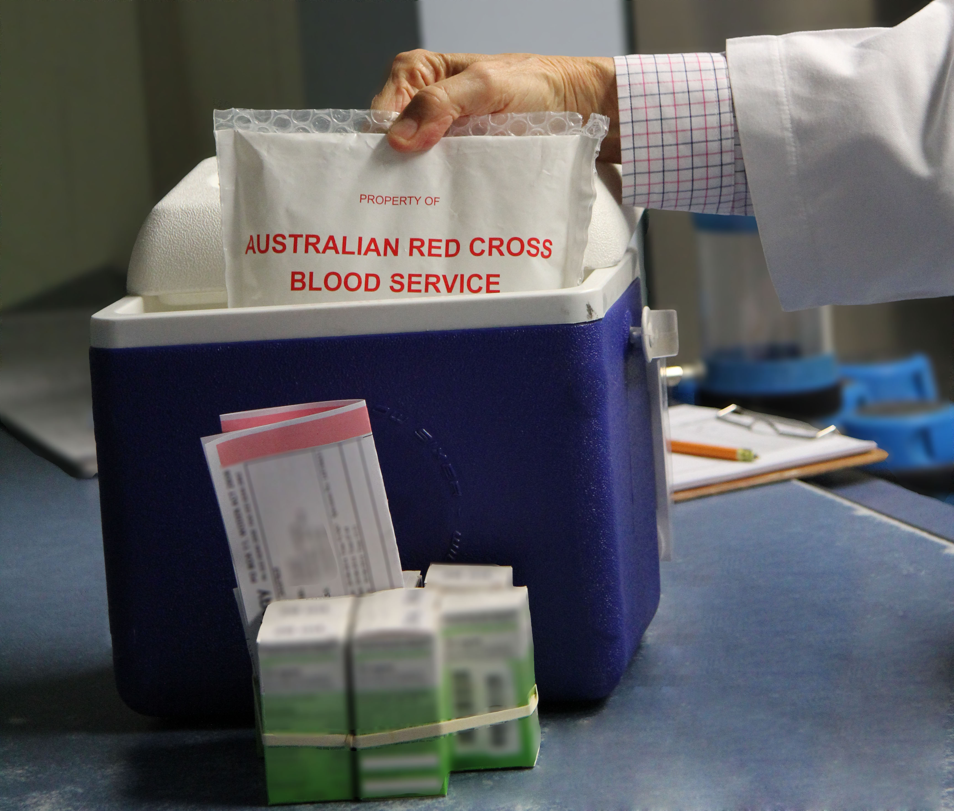

Transport and storage of SCIg product

There are different SCIg products your clinician can select for your treatment.

Some SCIg products require refrigerated transport and storage between 2 °C and 8 °C.

All products should be at room temperature before infusion commences to improve comfort levels. If a SCIg product requires refrigeration and has been brought to room temperature, it may not be returned to the fridge. Note the date the product is removed from refrigeration on the packet.

All products should be administered once opened.   
Any remaining product not used, should be discarded and recorded as such.

You should read the product information sheet provided with the medication, as well as taking advice from your clinician as the amount of time each product is out of refrigeration will have a different impact on the shelf life and expiry time.

Contact details

Hospital: Phone: Doctor: Phone: Treatment centre: Phone:

More information

Additional information can be obtained from the following sites:

* National Blood Authority www.blood.gov.au
* Australian Red Cross Blood Service www.mytransfusion.com.au
* National Health and Medical Research Council www.nhmrc.gov.au
* This brochure was developed with input from relevant consumer groups.

©National Blood Authority, 2016 

With the exception of any logos, registered trademarks and all images, this document is provided by the National Blood Authority under a Creative Commons Attribution-4.0 Australia (http://creativecommons.org/licenses/by/4.0/) license. The two images under ‘self-administered therapy with SCIg’ were taken at the Canberra Hospital.  The image under ‘Review Treatment Reviews’ section was sourced from Shutterstock. Images may only be downloaded and printed when the full publication is used for your own personal reference or for internal use within your organisation.  Permission must be sought from Shutterstock for any other use or modification of its image :http://www.shutterstock.com/licensing.mhtml. All other rights to images are reserved. Last updated: March 2016

Questions to ask your doctor

Below is a list of questions that you may like to ask your doctor to help you make an informed decision before agreeing to treatment:

* Why do I need this product?
* Are there any other treatment options?
* What are the expected outcomes of this treatment?

Your doctor should discuss any queries you have regarding the treatment and you should be offered written information. You have the right to ask questions and expect those questions to be answered.

Other questions I would like to discuss with my doctor:

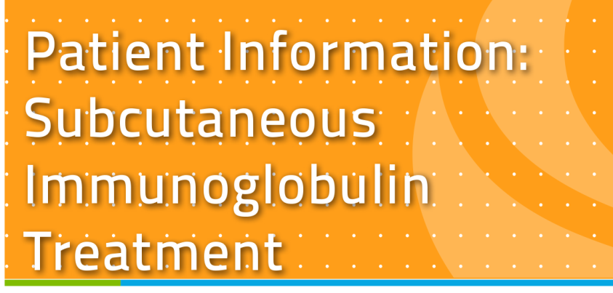



Your clinician has advised you that as part of your treatment you will be receiving medication called immunoglobulin. This product is funded and supplied   
by Australian governments for a specific range of indications defined within the Criteria for the clinical use of intravenous immunoglobulin in Australia Second Edition (Criteria).

Immunoglobulin is product derived from blood plasma donations which have been divided into different components. The immunoglobulin components are antibodies from the body’s immune (defence) system which fight infections and disease.

What is subcutaneous immunoglobulin  
treatment?

Subcutaneous immunoglobulin (SCIg) treatment is a method used to administer SCIg product by inserting a needle containing SCIg into the fat tissue under the skin.



Regular Treatment Reviews

All patients on immunoglobulin products must be regularly reviewed by a doctor. Depending on your diagnosis the immunoglobulin treatment may only be required for a limited amount of time. If you are prescribed continuing immunoglobulin treatment, regular consultations with your doctor help measure how the treatment is affecting your health, any dose adjustments to be made, and any side effects to be reported.

Your doctor will assess your response to the treatment and may stop your infusions temporarily to reassess your immune system or your response to treatment. Immunoglobulin treatment may not be effective and may no longer be required. Your doctor will advise you of when the reviews should be carried out.

Your doctor will also be required to periodically report on your response to treatment for you to continue to access immunoglobulin funded under the national blood arrangements.



Are there alternative treatments?

There may be other treatments for your condition. Discuss these with your doctor. Stopping treatment without first talking with your doctor can be dangerous.