>PREOPERATIVE BLEEDING RISK ASSESSMENT AND INTERVENTION
RESOURCE: QUICK REFERENCE GUIDE

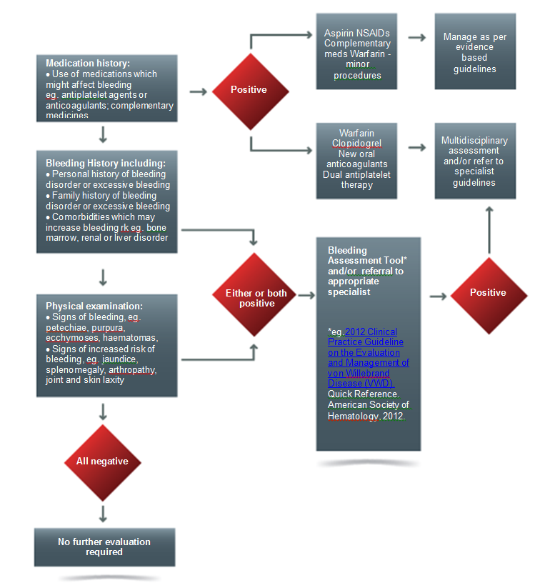

>PREOPERATIVE BLEEDING RISK ASSESSMENT AND INTERVENTION
RESOURCE:
QUICK REFERENCE GUIDE SUMMARY

Assessing and managing the risk of bleeding in a preoperative patient can be achieved by following the key steps:

1. Review medications, including complementary therapies:

- Manage as per evidence based guidelines, including specialist guidelines, local
protocols or referral where appropriate;

2. Perform initial bleeding history including personal and family history of bleeding disorder or excessive bleeding; and comorbidities which may increase bleeding risk:

- If positive use a Bleeding Assessment Tool (BAT) consisting of a standardised
bleeding questionnaire and bleeding score and/or refer for further assessment;

3. Perform a physical examination:

- If positive for signs of bleeding or comorbidities associated with increased risk of
bleeding use a BAT and/or refer for further assessment;

4. If all initial screens are negative, no further evaluation is required – routine preoperative coagulation screening is not recommended;

5. Neither preoperative point-of-care (POC) global coagulation assays nor POC INR measurement predict bleeding tendency;

6. Refer for specialist and/or multidisciplinary assessment and management, patients:

- undergoing high risk procedures;
- with haemostatic abnormalities associated with comorbid illness;
- on multiple antiplatelet and/or anticoagulant therapy; and those
- with known congenital bleeding disorders.

Details regarding these steps are outlined in the following pages. Considerations for incorporation of bleeding risk assessment into clinical practice using clinical practice improvement (CPI) methodologies can be found in Appendix 1.

